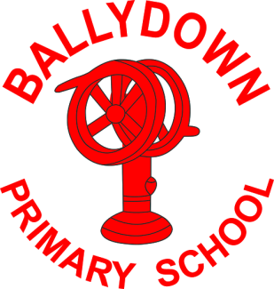
Ballydown Primary School & Nursery Unit
64 Lisnaree Road
Banbridge
Co Down
BT32 4JS
Tel:- 028 40662738

Principal: Mr B Murphy M.Ed. B.Ed. PQH(NI)

14th May 2020

Dear parents

Good morning everyone,

I hope this finds you and your families well.

Without wanting to overwhelm anyone with more information online, I do want to share this hyperlink to the Education Authority Literacy Service.

The Literacy Service have put together this general information document and four further areas providing advice and support for Reading, Spelling, Writing and Assistive Technology.

The title of the main document is, ‘Guidance for parents and carers supporting pupils experiencing literacy difficulties during COVID-19 related school closures,’ however, having looked through it, I can see that there is information which may be useful to all.

This link will take you to information which may be of interest to you in supporting and working with your child at home. It gives advice and guidance and also provides links to many excellent online packages.

https://www.eani.org.uk/services/pupil-support-services/literacy-service

Can I once again reiterate the fantastic job you are all doing with the home-schooling. We have all been so impressed by the level of commitment you have shown to keeping your child/ren up to date with their learning. I know it is no easy task, trying to ‘juggle’ it all. Please be reassured that you are doing so well under these difficult circumstances. Again can I remind you that we know you are all dealing with different circumstances at home. Just do what you can with your child and ‘pick and choose’ the most important activities to complete. Teachers have provided lots of activities, but you are under no pressure to do everything.

We have almost got to June and the online learning will greatly reduce from then!

Please do not hesitate in contacting me if you have any concerns or questions.

Thank you all,

Take care and keep safe.

Brian Murphy
Principal

Phone: 028 4066 2738
E-mail: bmurphy490@c2kni.net website: ballydownprimary.org.uk

