Ballydown Primary School & Nursery Unit
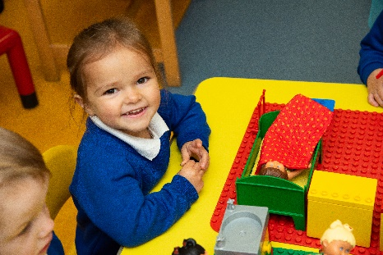

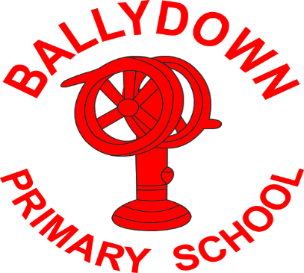
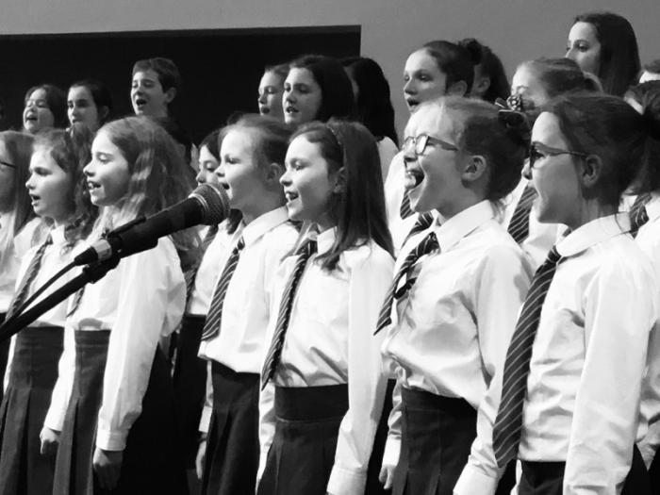
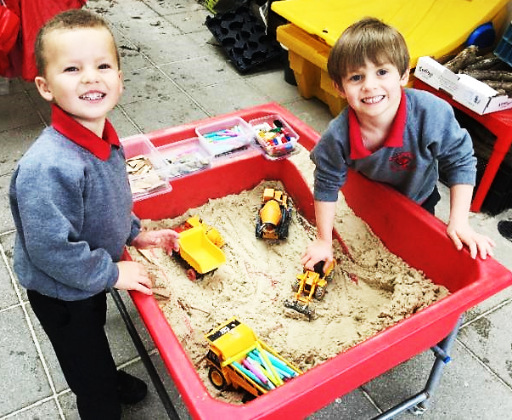
& Nursery Unit

School Information
2020

WELCOME to BALLYDOWN

Dear parent

On behalf of the governors, staff and pupils of Ballydown Primary School, I am delighted to welcome you to our school. We are very proud of all that we do and the reputation we have earned for providing quality teaching and learning in a family environment.
We have professional and dedicated staff who are committed to providing excellent teaching and learning opportunities for all our pupils in order to enhance their all-round development. I hope our prospectus provides you with a flavour of Ballydown life and encourages you to partner with us for your child’s early education.
As the true ethos of our school can only be fully experienced through a personal visit, you are more than welcome to book an appointment at any time. Alternatively come along to our annual Open Afternoon or one of our PTA events, to experience for yourself what makes Ballydown such a special place.
Mr Brian Murphy, Principal

“Children are so happy at Ballydown. They feel safe, secure, valued and challenged. Such a warm, caring, happy environment-couldn’t wish for more. Such hard working staff must be applauded.” Parent

VISION
It is our vision that Ballydown Primary & Nursery Unit is a place where everyone experiences a sense of belonging to the school family.
We are committed to providing a high quality learning environment in which pupils are motivated, challenged and supported so that they can be lifelong learners.
The school aims to maximise pupil potential in a safe, caring and child-centred community, where academic achievement, positive self-esteem, cultural diversity and the rights of the child are highly valued and respected.
We believe that pupils, staff and parents and members of the wider community should work together and cooperate with each other on an atmosphere of mutual respect and support, for the benefit of all.
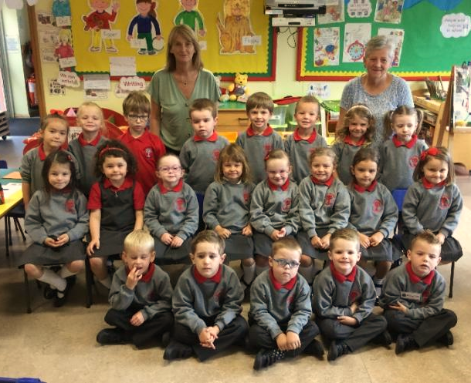
“This school is happy.” P3 pupil

“Ballydown is a wonderful school, with such lovely atmosphere.” Parent

Ballydown Primary School

Board of Governors & Staff

Composition of the Board

Rev Brian Martin Chairperson
Rev Liam Rutherford Vice Chairperson
Mr Brian Murphy Hon. Secretary

Transferor Representatives
Mrs Alison McQuiston
Mr Andrew Beattie

EA Representatives
Mrs Mary Mark
Mr Stephen Cassells

Parent Representatives
Mrs Mandy Gibson
Mr David Porter

Teacher Representative
Mr Trevor Russell

Principal
Mr Brian Murphy

The Governors are ultimately responsible for the overall management of the school.
Our duties include:
- The oversight of the curriculum
- The control of the budget
- The provision of information to parents
- The selection of staff
- The maintenance of the premises (shared responsibility with the EA)
- The Admission Policy
- Fostering links with the local community
TEACHING STAFFING

Mr B Murphy Principal
Mr T Russell Vice-Principal P7
Mrs D Russell/Mrs M Thompson P1
Mrs J Wright P1
Miss J White P2
Mrs S Lindsay P2/P3
Mrs A Irvine P3
Mrs B Glass / Mrs R Stewart P4
Mrs J Duke P4/P5
Miss J Orr P5
Mrs P Coulter/ Mrs M Thompson P6
Mrs K Blair P6/P7
Mrs N Walker Nursery
Mrs L Baird SENCO

Classroom Assistants
Mrs J Matchett/ Mrs J Eadie Mr S Cairns
Mrs P McCall Mrs H Gillham
Mrs J Eadie Clerical Assistants
Mrs M James Mrs M Graham
Mrs J Copes Ms S Oakes
Mrs W Elliott Building Supervisor
Mrs S Hinds Mr J Bingham
Mrs C Morrison Mr B Williamson/ Mrs T Horner
Ms T Gordon
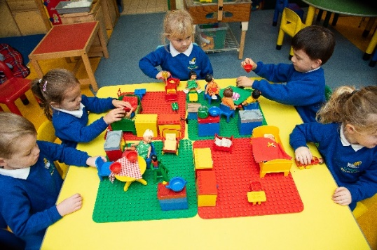
Nursery
We are delighted to have an excellent Nursery Unit as part of our school which is situated in the main school grounds. The building has an attractive, welcoming playroom, a quiet room for stories and a safe enclosed outdoor play area.
The Nursery is a warm, safe environment where children can experience learning through play; developing the skills necessary to take them on into Primary School. Our experienced Nursery staff are committed to ensure each child’s formative experience of education is a positive one. We endeavour to provide a happy and rewarding year in Ballydown nursery so that each child has a very positive start to their school career that sets them on the path of lifelong learning.

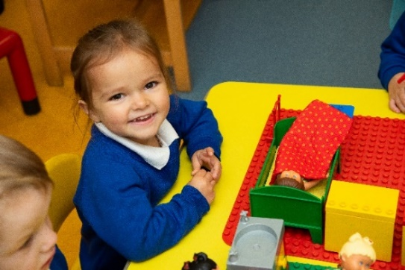
Ballydown Nursery is a full time nursery: The school day runs from 9:15am – 1:30pm.
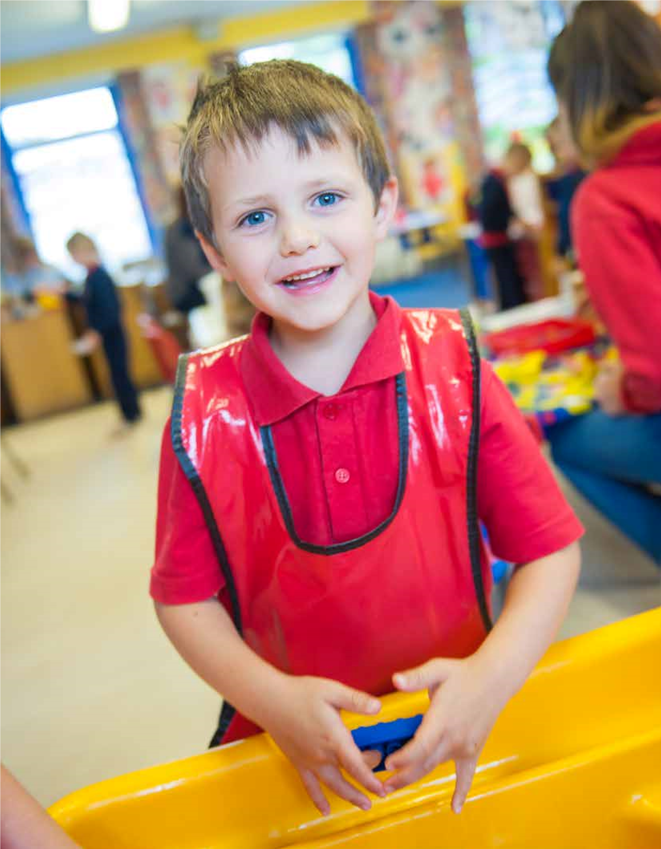
The Nursery is very much part of our school family and the children regularly use the main school facilities and visit for events throughout the year
“Gave me the best seven years ever!”
“I love this school… amazing memories.”
(
PUPIL COMMENTS
)
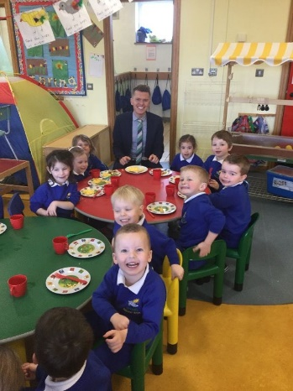
“…your team have done amazing work with the children!” Parent

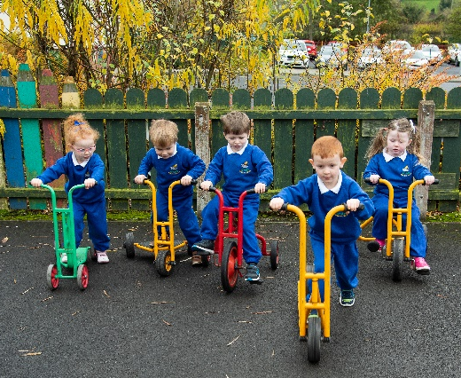
“I have loved my child’s nursery experience. What a great start to the children’s school experiences!” Parent
Teaching and Learning
In Ballydown we seek to provide your child with the best possible education. At Ballydown Primary School we have a strong tradition of academic achievement and are fully committed to maintaining these high standards. We are continually monitoring and evaluating what goes on in every classroom in order to embrace new ideas and improve the teaching and learning.
Children are grouped into three Key Stages within the Primary school P.1 and P.2 are The Foundation Stage; P.3 and P.4 are Key Stage 1; P.5, P.6 and P.7 are Key Stage 2. We have 11 classes from P1-P7. There are two P1 classes and then one straight class of each P2-P7. We also have three composite classes a P2/3, P4/5 and a P6/7. Our composite classes are made up of higher ability children who can work independently. Children in the composite classes follow the same work, topics and homeworks as the straight classes. We ensure that each year group mixes together in afternoon classes and during playtimes.
The World Around Us

(
incorporating History, Geography, Science and Technology
)
From Foundation through to Key Stage 2, pupils
develop their skills and experiences. They are
encouraged to explore, observe and question, and
work is often enquiry-based to promote investigative
and problem-solving skills.
Play Based Learning
Young children learn best when learning is interactive, practical, progressive and enjoyable. Here at Ballydown Primary School and Nursery Unit we recognise the value of learning in the foundation years and provide progressive, structured learning opportunities, through a programme of well planned, stimulating and challenging play based activities. The programme is a further development of activities your child did at nursery or playgroup and is incorporated into the daily timetable. All activities have a sound educational basis and aim, and include:
- Dramatic play in the home corner: eg shop, hospital. Garden centre, café etc
- Construction play with a variety of play blocks, Lego, k’nex etc
- Table top play eg jigsaws and games
- Creative play exploring art and design, music and drama
- Writing area using a variety of pages, scissors, pens, glues and writing boards
- Sand and water play
- Dough and clay play
- Small world play eg dolls’ house, farm, garage, farm etc

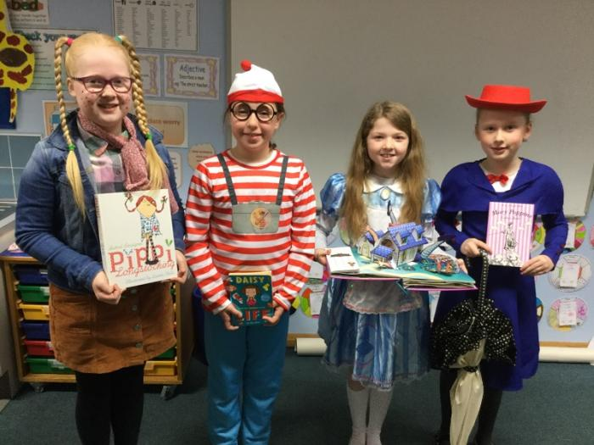
Language and Literacy
Language and literacy skills are highly valued and central to the ethos of Ballydown. It is divided into 3 components of Talking and Listening, Reading and Writing. Through the teaching of English, the pupils develop positive attitudes towards literacy. They are encouraged to communicate effectively, appropriately and accurately in a variety of contexts.
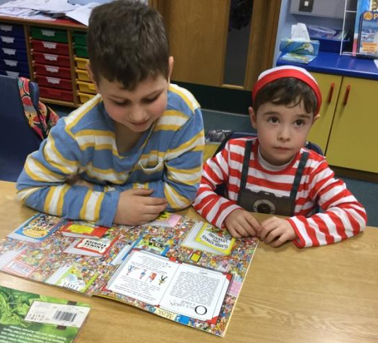
We highly value the importance of daily reading both with and to children. Every year we celebrate World Book Day. Recently we have begun work with local businesses in the Time to Read Programme. Our classroom assistants are also trained in the teaching of reading and offer valuable assistance to teachers and children.
Writing is taught as the children experiment with the patterns found in writing, before progressing on to formal letters and words they know. There are numerous opportunities for children to write from their earliest days in P1. All their writing is valued as they progress from making marks on the page, to single words, to simple phrases and to full sentences.

Mathematics and Numeracy
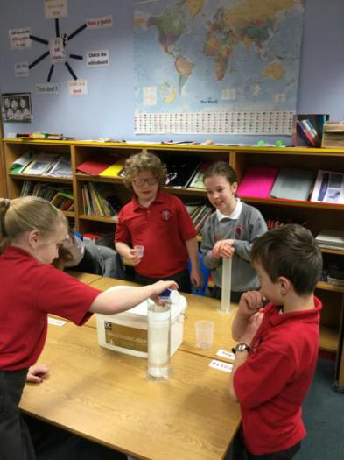
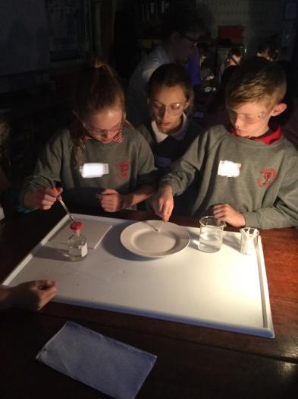
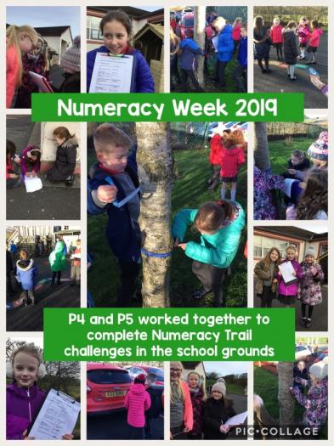
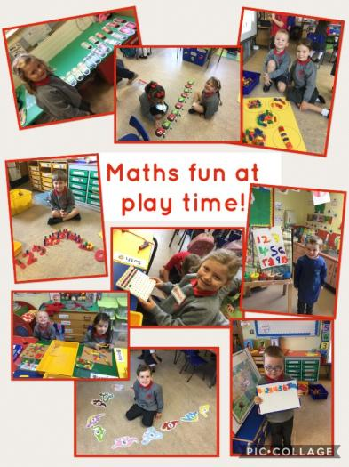
Acquiring mathematical skills is a vitally important part of a child’s education and as such, skills are utilised daily in adult life. Maths is a core subject in its own right as well as being integrated into other subjects in a cross curricular context. The Maths curriculum covers the areas of Number, Measures, Handling Data and Shape and Space. Processes (problem solving) permeate all of these areas. Teachers make use of a variety of teaching strategies and seek to foster in the children a positive attitude towards the subject. There is an emphasis on relating the content to real life situations, and so, investigations and puzzle work are an important part of the curriculum. Children work as individuals, in pairs and in groups to develop problem solving skills. Mental strategies and the ability to make mental calculations are developed through the use of a wide range of games.

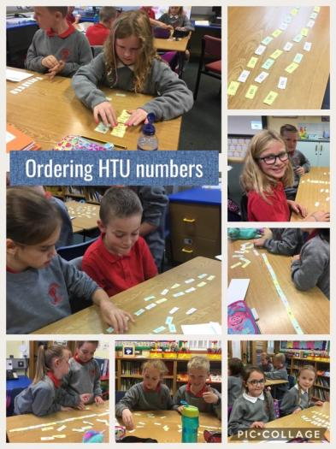

The Arts
Art and Design
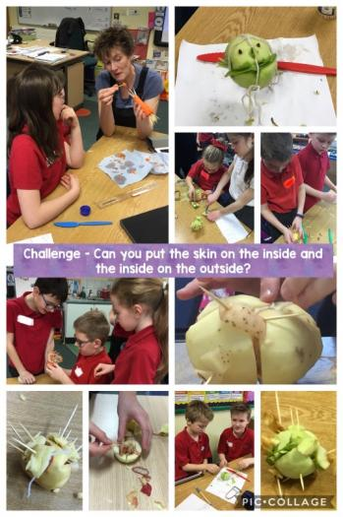
Art is a fun and enjoyable activity which encourages children to express their creativity.
In the Early Years, children experiment with a wide variety of materials and create both two and three dimensional pieces of art. This progresses through the years with children being taught basic skills and techniques while still allowing them to express their own creativity. All children are encouraged to look at and appreciate the work of other children along with the work of artists and designers and to appreciate the role art plays in creating a colourful and attractive learning environment. P2 and P5 work with the ‘Virtually There’ Project, working with local artists on a project and linking up using the web-cam.
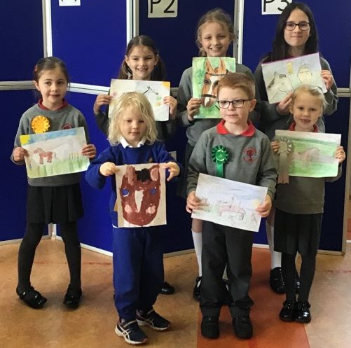
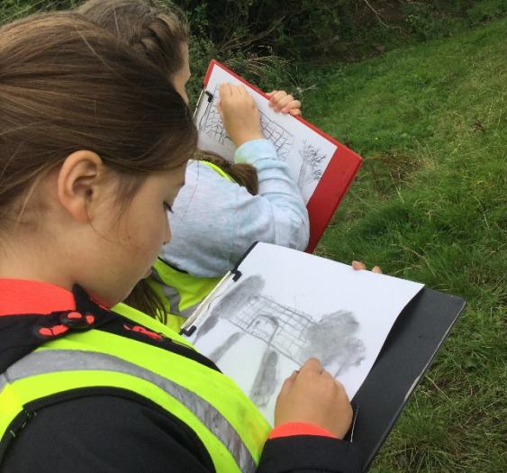

Music
Music provides opportunities for each pupil to appreciate, explore and express themselves. Lessons will develop creativity and confidence in music appreciation. All pupils participate in singing, composition and performance. Lessons are relevant and a much loved subject in the school curriculum.
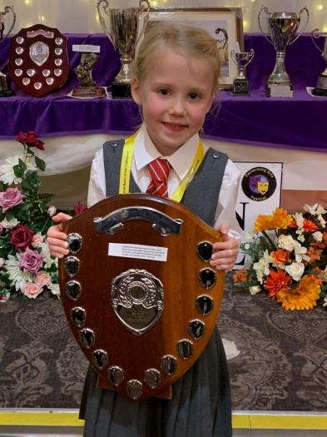
Throughout the school year we have had many music productions from all key stages. We are fortunate to have had workshops and orchestral sessions to inspire and encourage musical development. These are extremely important elements in children’s overall development and an important part of the life at Ballydown.

Drama
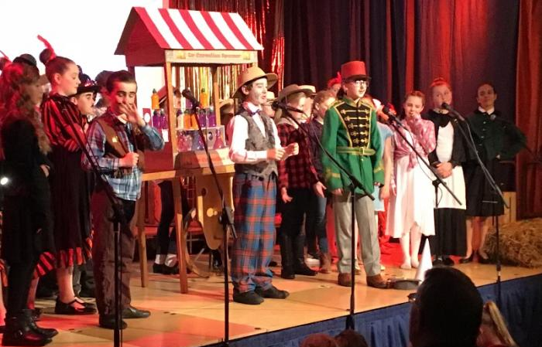
Children learn so much about themselves and others by participating in Drama activities. Through role play, they learn to empathise with peers and see things from another’s point of view. They also learn to turn take, speak clearly for an audience and express themselves confidently. Self-esteem and the fulfilment that comes from working with others towards a common goal is a great motivator for success and we at Ballydown firmly believe that the acquirement of such skills will be invaluable to our pupils as lifelong learners. Our hope is that all of our boys and girls in Ballydown will be

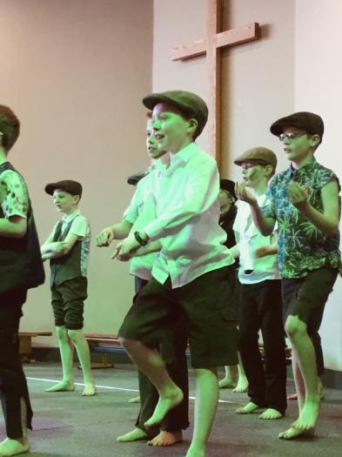
confident but empathetic individuals with a strong sense that they can make a difference in the world.
We believe that one of our strengths is the performing arts. We are very proud that every child, from nursery through to P7 will perform each year in a Nativity Play and thereafter participate in an annual Carol Service and shows from P4-7.
“Ballydown really gets the children involved in all aspects of the performance arts; it really builds their confidence.” Parent
Personal Development and Mutual Understanding (PDMU)
Focusing on emotional development, social skills, thinking skills, health, relationships and sexuality education and understanding of others.
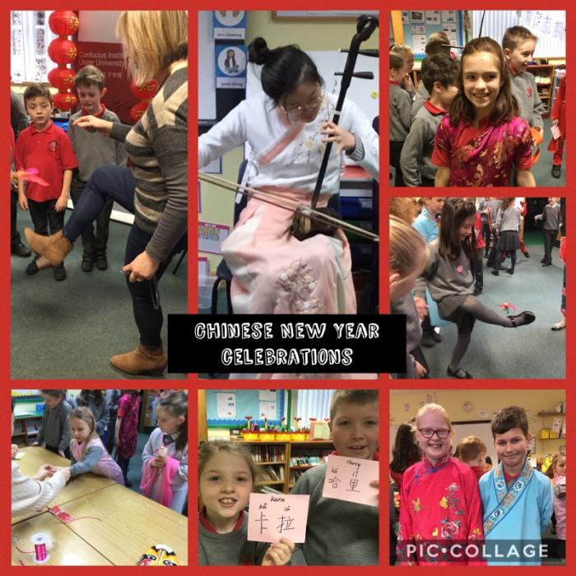
PDMU is linked to all aspects of life and work in school, flowing through activities and discussions in class, to learning how to interact with others in the playground and social situations. It is concerned with establishing a sense of personal responsibility, self-esteem, sensitivity to the needs of others and being part of a community both within the school and beyond it. Through a variety of activities children will gain a sense of self-value, allowing them to grow in confidence and become familiar with issues concerning their own physical and mental health. PDMU takes place via Circle Time, visits by outside agencies, storytelling, practical activities and is intrinsic to daily school life. In P4/P5 children have the opportunity to learn Mandarin and to learn about Chinese culture.

P.E. (Physical Education)
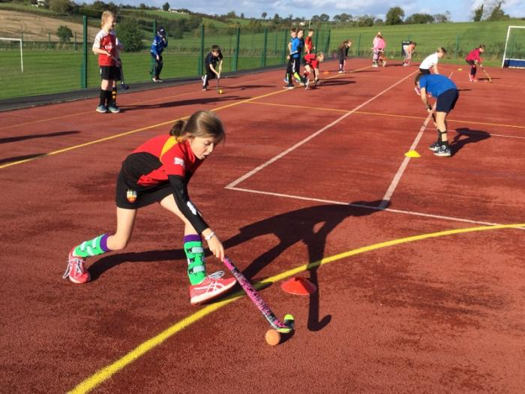
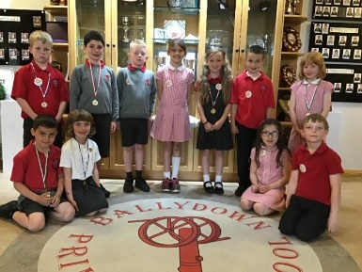
Our core physical education curriculum is delivered through regular lessons and is comprised of the five main elements of the Northern Ireland Curriculum – Games, Dance, Gymnastics, Athletics and Swimming (at Key Stage 2). All year groups have access to our large school hall for PE and p6/7 have an outside games session timetabled for one hour, one afternoon per week. We strongly believe in promoting physical fitness amongst our pupils and encourage them to develop healthy habits for life. Children take part in the annual Town Sports Event and Community Sports Week. Each y

R.E. (Religious Education)
Religious Education in Ballydown is based largely on the Christian faith. (Parents are entitled to withdraw their child from RE if they wish).
Through religious education children develop a positive sense of themselves and their beliefs, alongside a respect for the beliefs and values of others.
Weekly assemblies are taken by teachers, classes or visiting speakers/ministers, with separate assemblies for Foundation, Key Stage 1 and Key Stage 2 pupils. Children are encouraged to participate through singing and drama and every year each child from Nursery – P3 participates in a Nativity Play. P4-7 perform in a Carol Service each year for friends and family in the local church.

ICT (information communication technology)
At Ballydown, we believe that purposeful access to ICT across the curriculum will motivate and increase engagement and achievement in our pupils and prepare them for the future. ICT allows children to;
“break down the walls of the classroom.”
Creativity and digital literacy are becoming vital skills for the 21st century and will be valued in all areas of employment. It is with this in mind that we at Ballydown, have decided to invest in our pupils’ future and provide the children with the necessary tools to promote optimum learning.
Each class has Interactive whiteboards, 8-10 iPads and share several desktop computers in a resource area.
With the use of an iPad, all pupils are able to demonstrate their knowledge and understanding in any area of the curriculum through creative means and teachers are offered the opportunity to access a wealth of resources and information that can support pupil led learning and a variety of learning styles.
This effective use of technology has been an exciting development and has presented both pupils and teachers alike with opportunities to enhance their ICT skills in a creative and productive way. We are continually undergoing training and upgrading and adding to ICT equipment to ensure that we are always up to date with the latest technology.

Tracking Pupil Progress
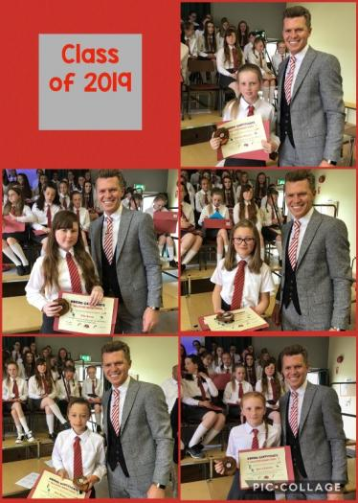
The progress of each individual child is closely monitored throughout their time at Ballydown. This is to ensure that every boy and girl reaches his or her full potential. Alongside the class teacher each child will highlight areas for improvement in Literacy, Numeracy and another area of school life. This provides a focus for each child to work towards and a sense of achievement as targets are met. Achievements are acknowledged and celebrated within the classroom and beyond, and children grown in confidence and self-esteem.
Our P7 pupils transfer to a range of post primary schools:
Banbridge Academy, Banbridge High, Dromore High, Rathfriland High, Friends, Victoria College, Royal Belfast Academical Institution

Learning Support
At Ballydown, we are committed to meeting the specific individual learning needs of all children whether they are achieving significantly beyond the rest of their year group (more able/ high performers), or experiencing learning difficulties. Some children progress within their own peer group in which the class teacher provides a range of differentiated activities. Other children require more specific help. In consultation with the parent and class teacher, some children may receive additional input from the Learning Support Team or relevant outside agencies. We aim to ensure that every child can access the curriculum to the best of his or her ability and is nurtured and supported in their learning. An Individual Education Plan (IEP) will be drawn up for these children and their progress will be monitored and assessed. Parents/guardians will receive copies of these IEPs and be kept informed of their child’s progress throughout the year.
Every child in our school is part of the Ballydown family and can expect to be provided with a suitable environment and level of learning experience appropriate to his/her ability.

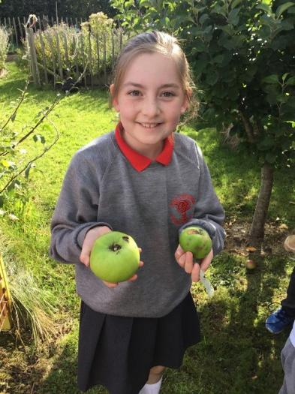
Enriching The Curriculum
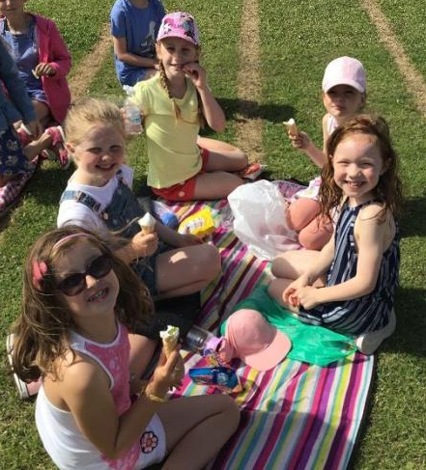
In Ballydown, we believe in fostering the development of the whole child. While academic achievement is important, we also place great value in promoting the physical, social, emotional and spiritual wellbeing of each boy and girl. To this end we support the excellent teaching and learning that goes on in our classrooms with a wide range of extra-curricular and supplementary activities.
These include:
- Music tuition
- After school sports (including football, athletics, rugby, netball, Irish Dance, hockey, table tennis)
- Other after school clubs (art club, ECO club, miniversity, speech and drama)
- An active Student Council
- Quizzes and competitions
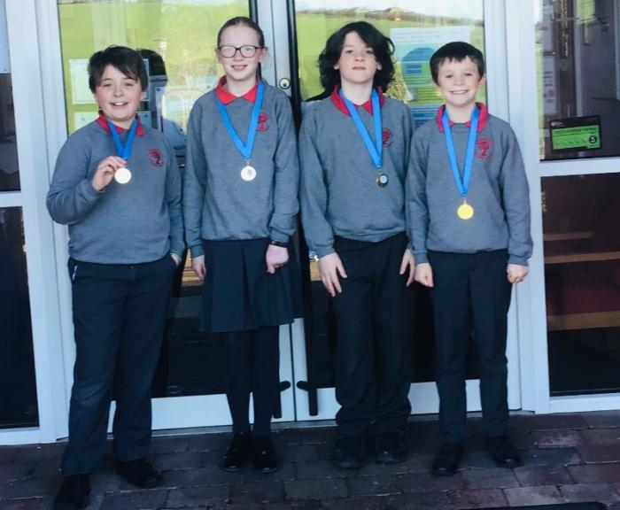
- Buddy system in our playgrounds
- Visitors to School
- Educational School trips
- Residential visits
- School productions and performances
- Assemblies

SHARED EDUCATION
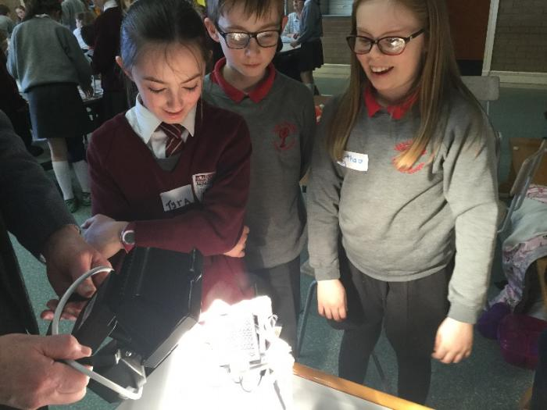
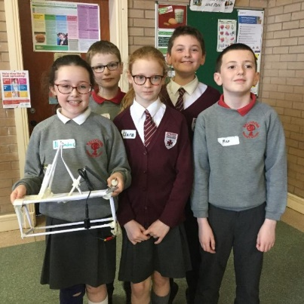
We work closely with our partner school St Francis’ Primary promoting shared education, funded through the Peace IV Project. Children enjoy lots of activities and trips together benefitting them both educationally and socially.

Ulster Scots
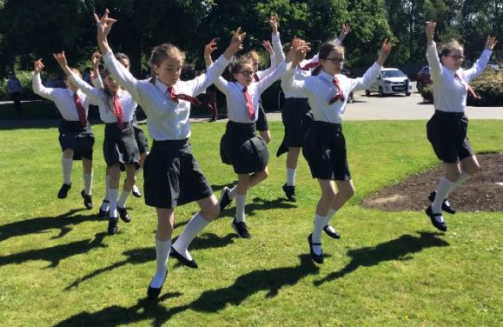
We celebrate our Ulster Scots heritage and are very proud of our status as a Flagship School for Ulster Scots. Children have the opportunity to learn highland dance and to play the fiddle. Each year P7 pupils take part in a Burn’s Assembly and travel to Scotland to the home of Robert Burns.

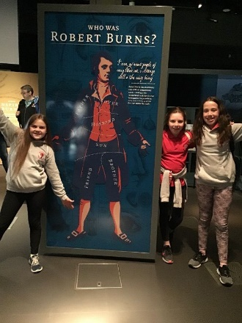

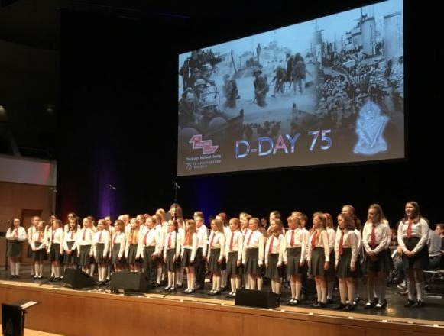
School Choir
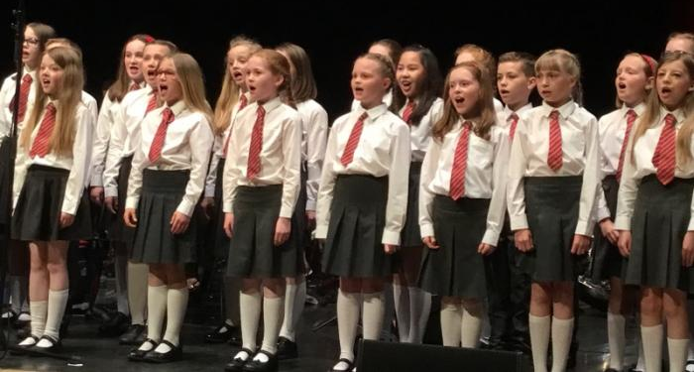
Our school choir consists of around 50 pupils from P5-7. We meet each week building our vocal skills and working together as a team. We enjoy singing in school for our peers and family. We love getting the opportunity to sing; performing in various public venues. Our most honoured performance was having the opportunity to perform at the Waterfront Hall at the D-Day 75 Celebration.
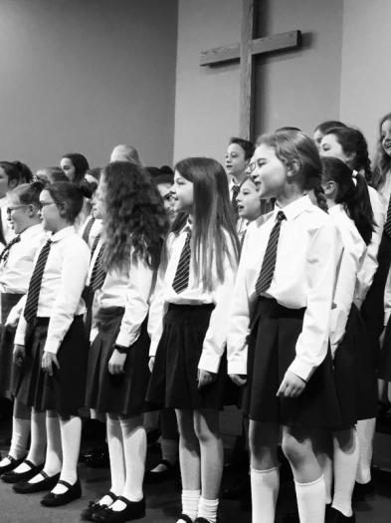

Musicians
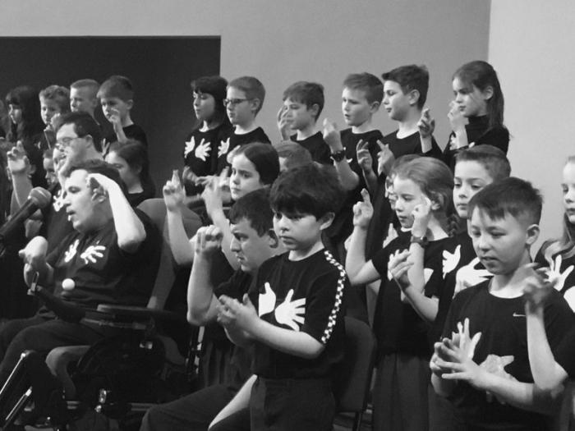
From P3-P5 pupils are given the opportunity to learn an instrument. Those who have musical flair for a particular instrument can have private music lessons. We currently have lessons in violin, guitar and woodwind. Each year we have Spring Concert in which all pupils form P5-P7 have an opportunity to perform on stage, showcasing the musical talents of our pupils. Our P5 children work with a local community group for Adults with learning difficulties. The children learn Makaton and perform with the group in our annual Spring Concert.
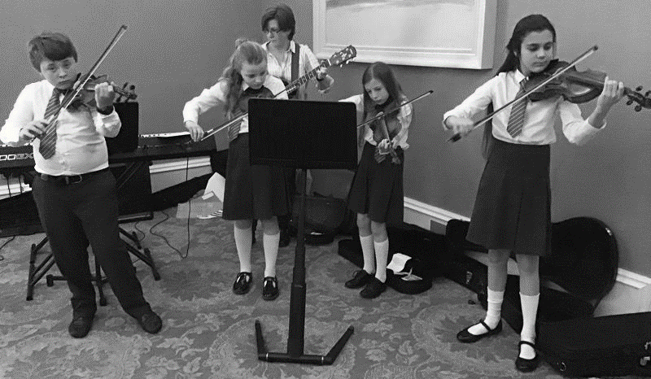
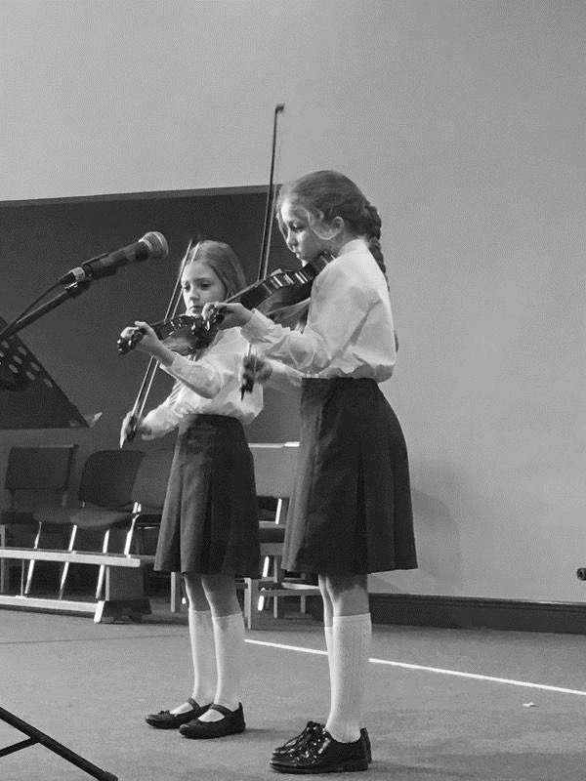
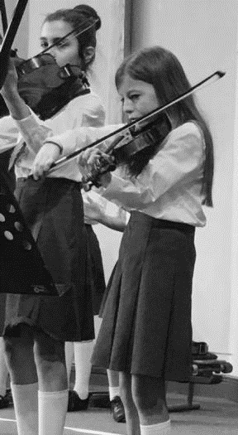

After School Activities
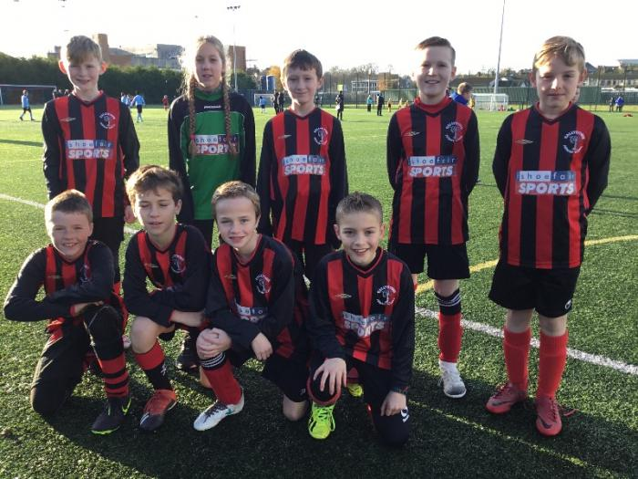
In Ballydown, we believe in developing the whole child and are very proud of the wide range of after school activities which we offer, catering for children interested in sport, music, eco, cookery, technology and art.
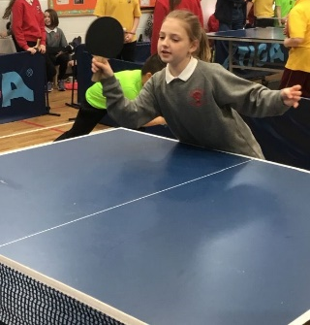
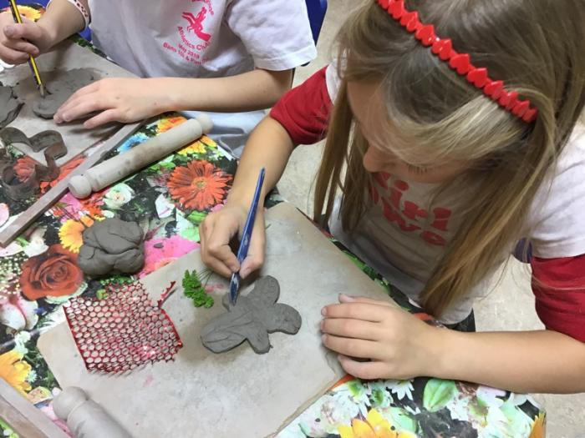
Many of our teams and groups are encouraged to enter competitions with great success, while others simply foster enjoyment and lead to lifelong interests.
Many of the activities are taken by teachers within the school, but for some external specialists are used.
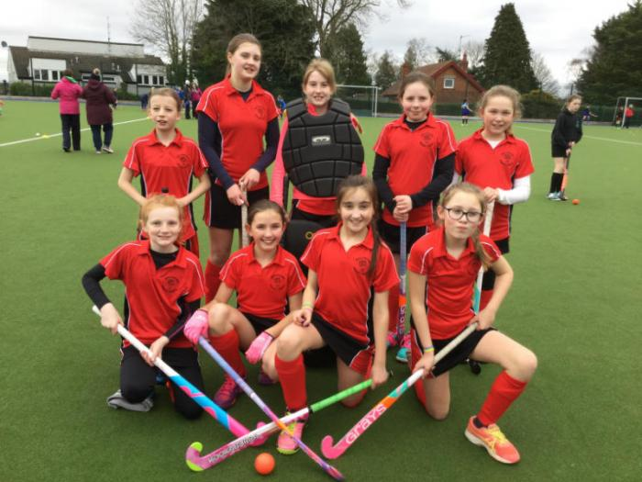
There may be some variation from year to year, but they include the following:
Football, hockey, netball, art club, ECO club, table tennis, Miniversity, Irish Dancing, Speech and Drama, rugby, ballet, hip-hop, cross country runnning, gymnastics, scripture union.
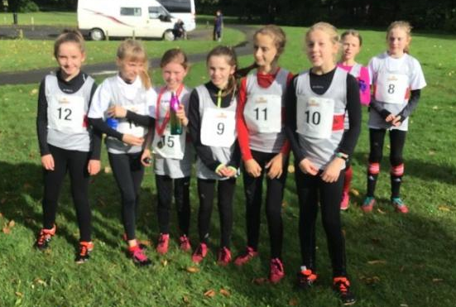
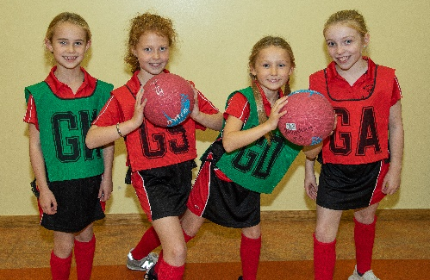

Show Jumping Team
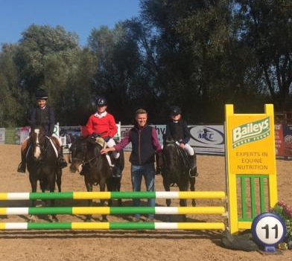
We are delighted to have our own school show jumping team. We have a lot of enthusiastic riders in our school, including our principal Mr Murphy. The team compete in the Inter-Schools Show jumping league.

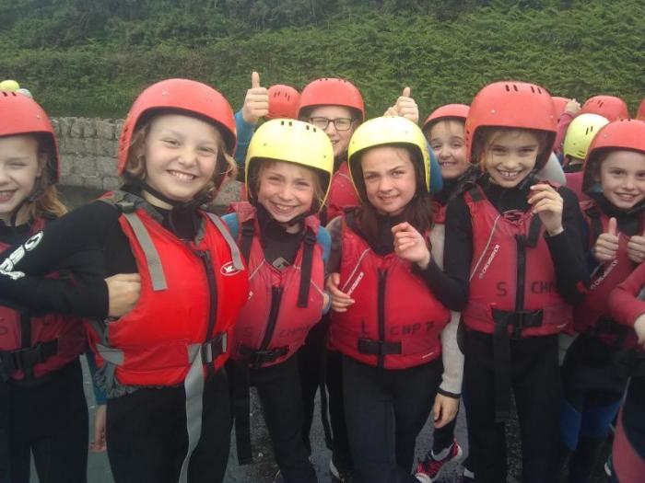
Educational Visits
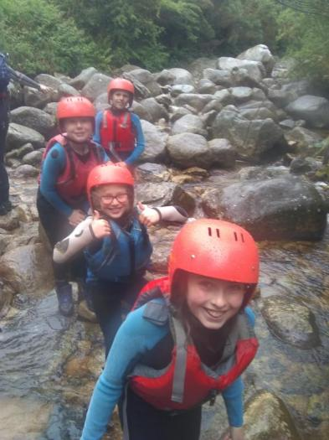
Educational visits are a fun and exciting way of widening pupils’ experiences, promoting relationships, stimulating new interests and setting challenges in new situations. They make a vital contribution to our pupils’ personal and social development, foster independence and help develop positive attitudes towards the environment.
The trips range from day trips from primary 1-7, and residential trips in primary 7.
All trips are linked to the curriculum and topics taught within each year group, and they act as in interesting, stimulating and activity based way to reinforce topics.
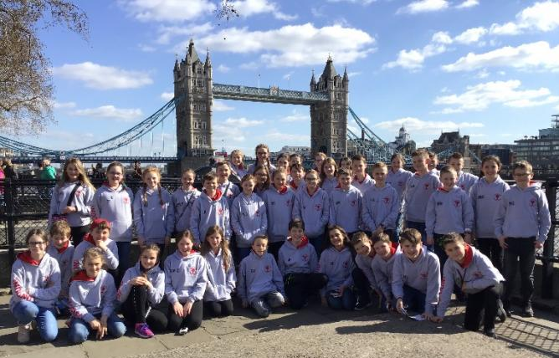
P5 Pupils go on an Outdoor Pursuits Trip.
In P7 children go on a residential trip to London.
“My P7 trip is my favourite memory of P7.” Pupil
Saving schemes are put in place the previous year for our residential trips to spread the cost.

The Daily Mile
The Daily Mile is an initiative to encourage pupils to exercise for 15 minutes every day as part of their routine. We have decided as a school to implement this idea across the school from Primary 1 to Primary 7. Each year group are encouraged to walk, jog or run around the school perimeter. Their aim will be to complete as many laps as they can within the time and make small improvements each week. There is a monthly prize for the class who complete the most miles over the month. This activity will benefit the children both physically and mentally. It can help children to focus and concentrate in the classroom and raise their attainment. As a school we are really excited about this opportunity for both staff and pupils to develop healthy habits for life.

“Thank you Ballydown for making school such a great experience for our children.” Parent

Positive Behaviour
We believe that effective learning can only take place where there is a standard of good behaviour. Every pupil has the right to be educated in an atmosphere which is conducive to learning, and there is an expectation that every pupil has a responsibility to contribute to the creation of such an atmosphere. Our positive behaviour policy aims to cultivate in pupils and acceptance and recognition of responsibility for their own decisions and actions – and indeed for their consequences.
Positive behaviour leads to a happy and orderly school environment in which:
- Everyone feels safe and cared for
- Good personal relationships can be developed
- There is mutual respect among all members
- Effective learning can take place
Behaviour in Ballydown Primary School is of a high standard and is promoted through:
- A positive atmosphere where praise, encouragement and rewards are given
- The involvement of children in the rule making process
- Communication with parents
- An awareness of preventative measures
- Corrective action when necessary
- Supportive actions from appropriate agencies for behaviour of serious or ongoing concern
- Sanctions when appropriate
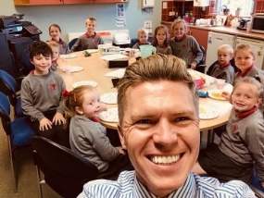
Student of the Month Award
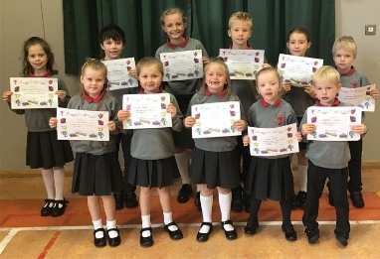
Each month Mr Murphy selects a target for the children to work towards. Each class teacher choses a winner at the end of the month to receive an award and enjoy ‘Tea with the Principal’!

Communications with Parents and Friends
Our aim is to work closely alongside parents in their child’s education. To this end, we believe that excellent communication is vital. We operate an ‘open door’ policy: parents are welcome to speak to staff at the beginning and end of the school day about minor matters or to make an appointment to discuss more serious issues. We also hold parent-teacher consultations twice a year to enable parents to meet with their child’s teacher to discuss his or her progress and wellbeing.
Beyond this, we seek to communicate effectively with parents and indeed the wider community in a variety of ways
- Our School Website provides information about each year group, after school activities and key dates and events.
- Each month, we produce a monthly news sheet which can be viewed on the school website or as a printed copy on request. Our news sheet allows us to share photos and information of what has taken place in school each month as well as letting parents know about upcoming events. It also provides the perfect forum on which to celebrate all that our children are doing.
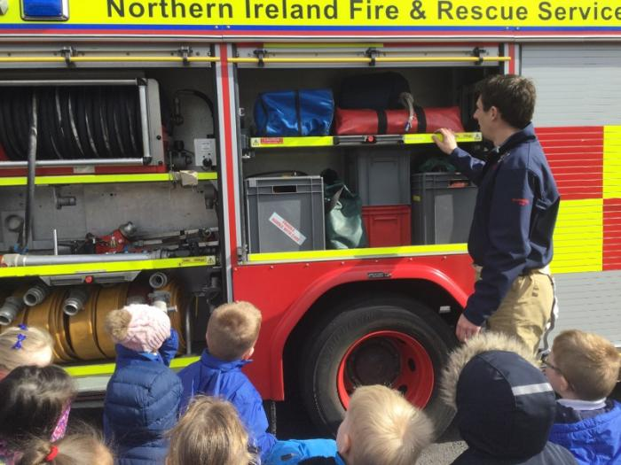
- We feel strongly that as the primary school in this area we are an integral part of our local community and it is important that we get involved with the people who live around us. We participate in local church services, our choir sings in the shopping centre ……., our children contribute articles regularly to the Banbridge Chronicle and we often support local charities. Members of the community are invited into our school throughout the year; to our Christmas concerts, Open Day, coffee mornings and PTA events. We foster a family ethos and this extends beyond our doors to all.
- We work with local services in the community such as the Fire Service, PSNI, dentists, vets and local businesses.
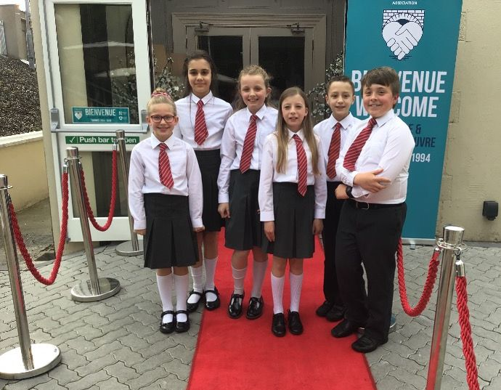

PTA
We are very fortunate to have a well organised and highly motivated group of parents who run our PTA. Over the course of each year, they organise a wide variety of fundraisers which not only provide much needed funds for our school and its pupils, but also some great days out and fun filled activities. Regular events include our Movie Nights, Fun Run, Santa Fun Run, Ballydown Does Balmoral. Our most recent success was a Gala ball celebrating the school’s 80th Anniversary.
- New members and helpers are always welcome
For more information please contact our Chairperson Mrs Lisa Dodds or speak to Mr Murphy.

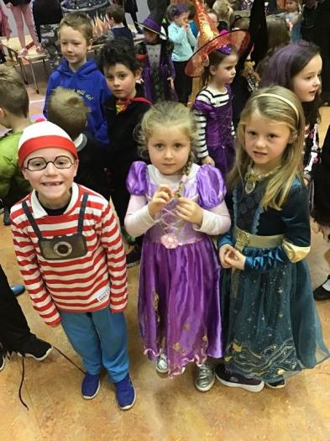

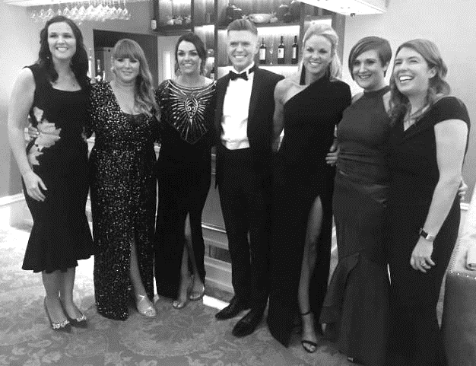

Food in School
School Meals
School meals are cooked on the premises. Menus are posted monthly on our website. Dinner money is collected on Monday mornings. Water is always available and children are encouraged to drink water regularly throughout the day.
Healthy breaks
We encourage all children to bring a healthy snack for break times. Our school is also a nut free zone. If your child has any allergies speak to use and we can make arrangements to cater for this.
Uniform and School Day
At Ballydown Primary School our uniform gives the children a sense of identity and belonging. The children take pride in wearing their uniform and visitors often comment on how well turned out our children are.

Girls:
White shirt or Red polo shirt
Grey skirt or pinafore
Red gingham dresses in summer (optional)
School V-neck sweatshirt or cardigan
School tie for formal occasions
Grey/Red tights or white socks
Black shoes or plain black trainers

Boys:
White shirt or red polo shirt
Grey trousers/grey formal shorts
School V-neck sweatshirt
School tie for formal occasions
Black shoes or plain black trainers

PE Uniform:
Our PE uniform consists of black shorts/ cycle shorts and white polo shirt

The School Day
School begins 9.15am
Break time 10.45-11.00am
Lunch time 12-12.40/ 12.30-1.10
P1-P3 finish 2.00pm
P4-P7 finish 3.00pm
A range of after school activities run in the afternoons until 4pm.
Nursery school day 9:15am -1.30pm

Finally
I hope you have enjoyed browsing through our prospectus. More information about Ballydown Primary School and school life can be found on our school website. If you have any further questions please do not hesitate to contact me.
Thank you,
Mr Brian Murphy

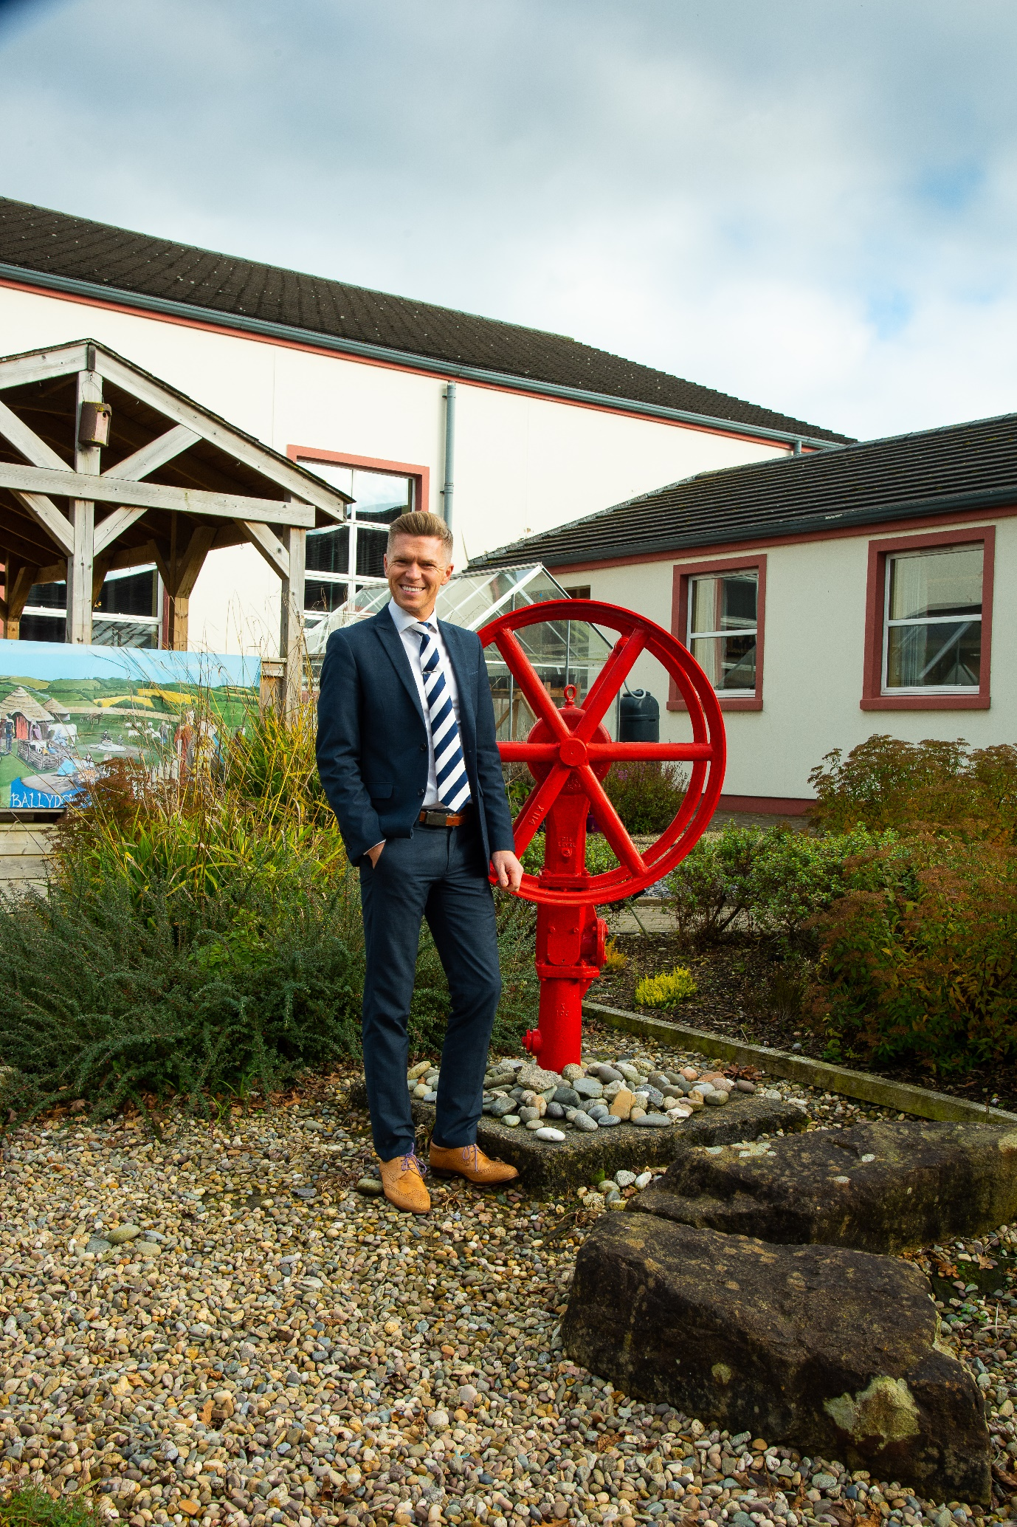

Children learn so much about themselves and others by participating in Drama activities. Through role play, they learn to empathize with peers and see things from another’s point of view. They also learn to turn take, speak clearly for an audience and express themselves confidently. Self-esteem and the fulfilment that comes from working with others towards a common goal is a great motivator for success and we, at Abbey firmly believe that the acquirement of such skills will be invaluable to our pupils as life long learners. Our hope is that all of our boys and girls in Abbey will be confident but empathetic individuals with a strong sense that they can make a difference in the world.
We are proud that every child, from Nursery through to P3 will perform each year in a Nativity Play and thereafter, participate in an annual Carol Service and shows from P4-7.

M roughout the school year we have had many music productions from all key stages. We are fortunate to have had drumming workshops and orchestral sessions to inspire and encourage musical development. These are extremely important elements in children’s overall development and an important part of the life at Abbey.
usic provides opportunities for each pupil to appreciate, explore and express themselves. Lessons will develop creativity and confidence in music appreciation. All pupils participate in singing, composition and performance. Lessons are relevant and a much loved subject in the school curriculum.

Music provides opportunities for each pupil to appreciate, explore and express themselves. Lessons will develop creativity and confidence in music appreciation. All pupils participate in singing, composition and performance. Lessons are relevant and a much loved subject in the school curriculum.

