Nursery Prospectus 2021

Ballydown Primary School
Nursery Unit

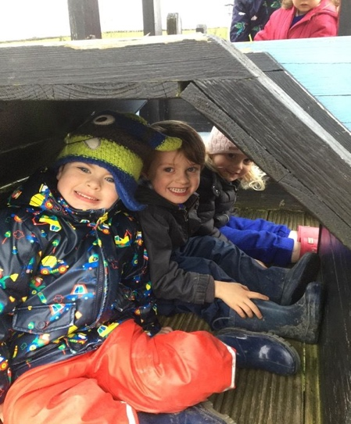

2021

Ballydown Primary School Nursery
64 Lisnaree Road Banbridge
Co. Down
Tel: 028406 62738 Fax:028406 22357

Principal Mr B Murphy M. Ed B.Ed PQH
Chairman of Board of Governors- Rev Martin

Dear Parent,

I have great pleasure in forwarding our prospectus. Thank you for considering Ballydown’s Nursery Unit as one of the options for your child’s Nursery education. I hope the information enclosed, though brief, will be informative and helpful in your quest to find the best provision.
Set amid the rolling hills of South Down, on the edge of the Bann valley, Ballydown Nursery has the ideal location to encompass the traditional values of a rural location, yet on the edge of modern urban living.
Our Nursery Unit is a newly, purpose built, bright, stimulating, learning environment. It blends both natural and commercial resources to provide enriched, fun learning experiences for all the children. Such a wonderful environment enables the children to explore their individual strengths and to develop their unique skills with confidence, which, in turn, allows them to gradually become independent learners.
It is recognized by the staff that starting Nursery is a big step in your child's life. If given the opportunity, I look forward to welcoming you and your child, and in partnership we will endeavour to make this a happy and successful period in your child’s education. One thing I can guarantee is that your child will have a fun-filled year at Ballydown Nursery.
Yours sincerely

B Murphy

B Murphy
PRINCIPAL

The Role of Parents and Home-school Partnerships
We are aware of the tremendous input that you, as parents, have already made in the education of your child and we acknowledge your role as the child's first educator. From birth, children learn many things. You have already played an important part in this process of learning and we look forward to developing a partnership with you in these valuable early years.
Starting Nursery is a very exciting time for young children and together we can make it a very happy and rewarding time. Parents have a significant responsibility in supporting their children through nursery as they settle in and learn.

Before starting nursery, talk to your child about coming to Nursery and about the things they will be doing and the people they will be meeting. It is helpful to use our names so that they will be familiar with them.
When your child starts Nursery you will find that only a few children will start on the same day. By admitting the children a few at a time we find that the children are able to settle more quickly and easily into the Nursery routine, making the transition from home to Nursery as smooth as possible for both children and parents.
It is important to remember that young children vary tremendously in the way in which they react to new experiences so do allow your child plenty of time to get used to nursery - some children may take longer to settle than others.
Unfortunately, due to restrictions we are unable to hold Our Open day. However, if you would like a tour of our nursery please phone the office and I will arrange for an opportunity for you to visit the Nursery. If Ballydown becomes your preferred option, I look forward to welcoming you and your child and in partnership, we will endeavour to make this a happy and successful period in your child’s education.

Ballydown Primary School caters for a current enrolment of 313 children, with an additional 26 children in the nursery.

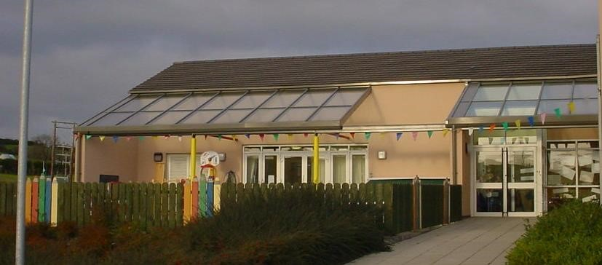

The Nursery has a large playroom, reading/quiet room, partially covered, enclosed out-door play area with hard and soft play surfaces. The toilet facilities are just off the main playroom. All furniture and resources are colourful and inspiring, encouraging learning in a fun way.

Your child will have the privilege of enjoying all of these facilities, in a happy, friendly and secure environment.

Nursery staff

Principal of Ballydown Primary School and Nursery Unit is Mr B Murphy

- Your child’s teacher will be Mrs Nicola Walker

- The Nursery Assistant is Mrs J Matchett

- Mrs A Irvine is the Designated Teacher for Child Protection and can be contacted via the main school office.

Others who help;
- The school secretaries are Mrs Muriel Graham & Ms Sarah Oakes
- The school caretaker is Mr Jeffrey Bingham
- The school meals supervisor is Mrs Sharon Annett
Times of Nursery Unit

- Arrival from 8.55am to begin at 9.15am

- Collection 1.25 - 1.30pm

Please note:- children are expected to arrive and depart, with an adult, within these times to make best use of their Nursery experiences. It is important that children are collected promptly at the end of each day as they can become anxious if left waiting. Your support in this also helps us maintain the smooth running of the Nursery day.

Admissions Procedure

Having applied the admissions criteria, children selected for enrolment, are welcomed into Nursery in small groups over a four-week period.

Induction

Unfortunately, this year due to ongoing covid-19 restrictions we are unable to hold our open day.

For those who are accepted into our Nursery:
    - a parents’ information evening will be held in June 2021 to outline curriculum provisions and general daily routines.
    - in August 2021 parents and children are welcomed to an introductory session in the Nursery.

Nursery Aims and Objectives

0ur overall aim is to:

Provide a broad and balanced curriculum to ensure that children's individual differences are recognized and their needs met, so that all aspects of the children's growth and development are promoted.

We are going to achieve this aim by fulfilling 3 key objectives

1

2

3

➢ Key Objective 1
Provide a stimulating, happy environment where children are safe and secure.

➢ Key Objective 2
Provide activities that will facilitate effective delivery of the 6 key areas of the nursery curriculum, in a creative and innovative fashion.

➢ Key Objective 3
Involve parents in their children’s education by establishing and maintaining vital links between child, home and school.

Key Objective 1
Provide a stimulating, happy environment where children are safe and secure.

SAND AND WATER PUZZLES

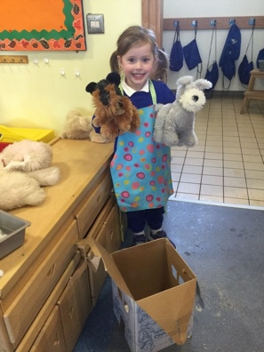
ROLE PLAY
CONSTRUCTION

MUSIC

PLAYDOUGH

ART & CRAFT

BAKING
LIBRARY CARING STAFF

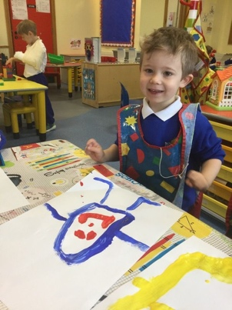
GOOD PARENT –TEACHER LINKS COMPUTER
MULTI PURPOSE INDOOR AND OUTDOOR FACILITIES

PASTORAL CARE DIMENSION

Key Objective 2

Provide play activities that will facilitate effective delivery of the 6 key areas of the nursery curriculum to help nurture your child’s ability for imaginative, creative, self-expression and knowledge of the world around them.

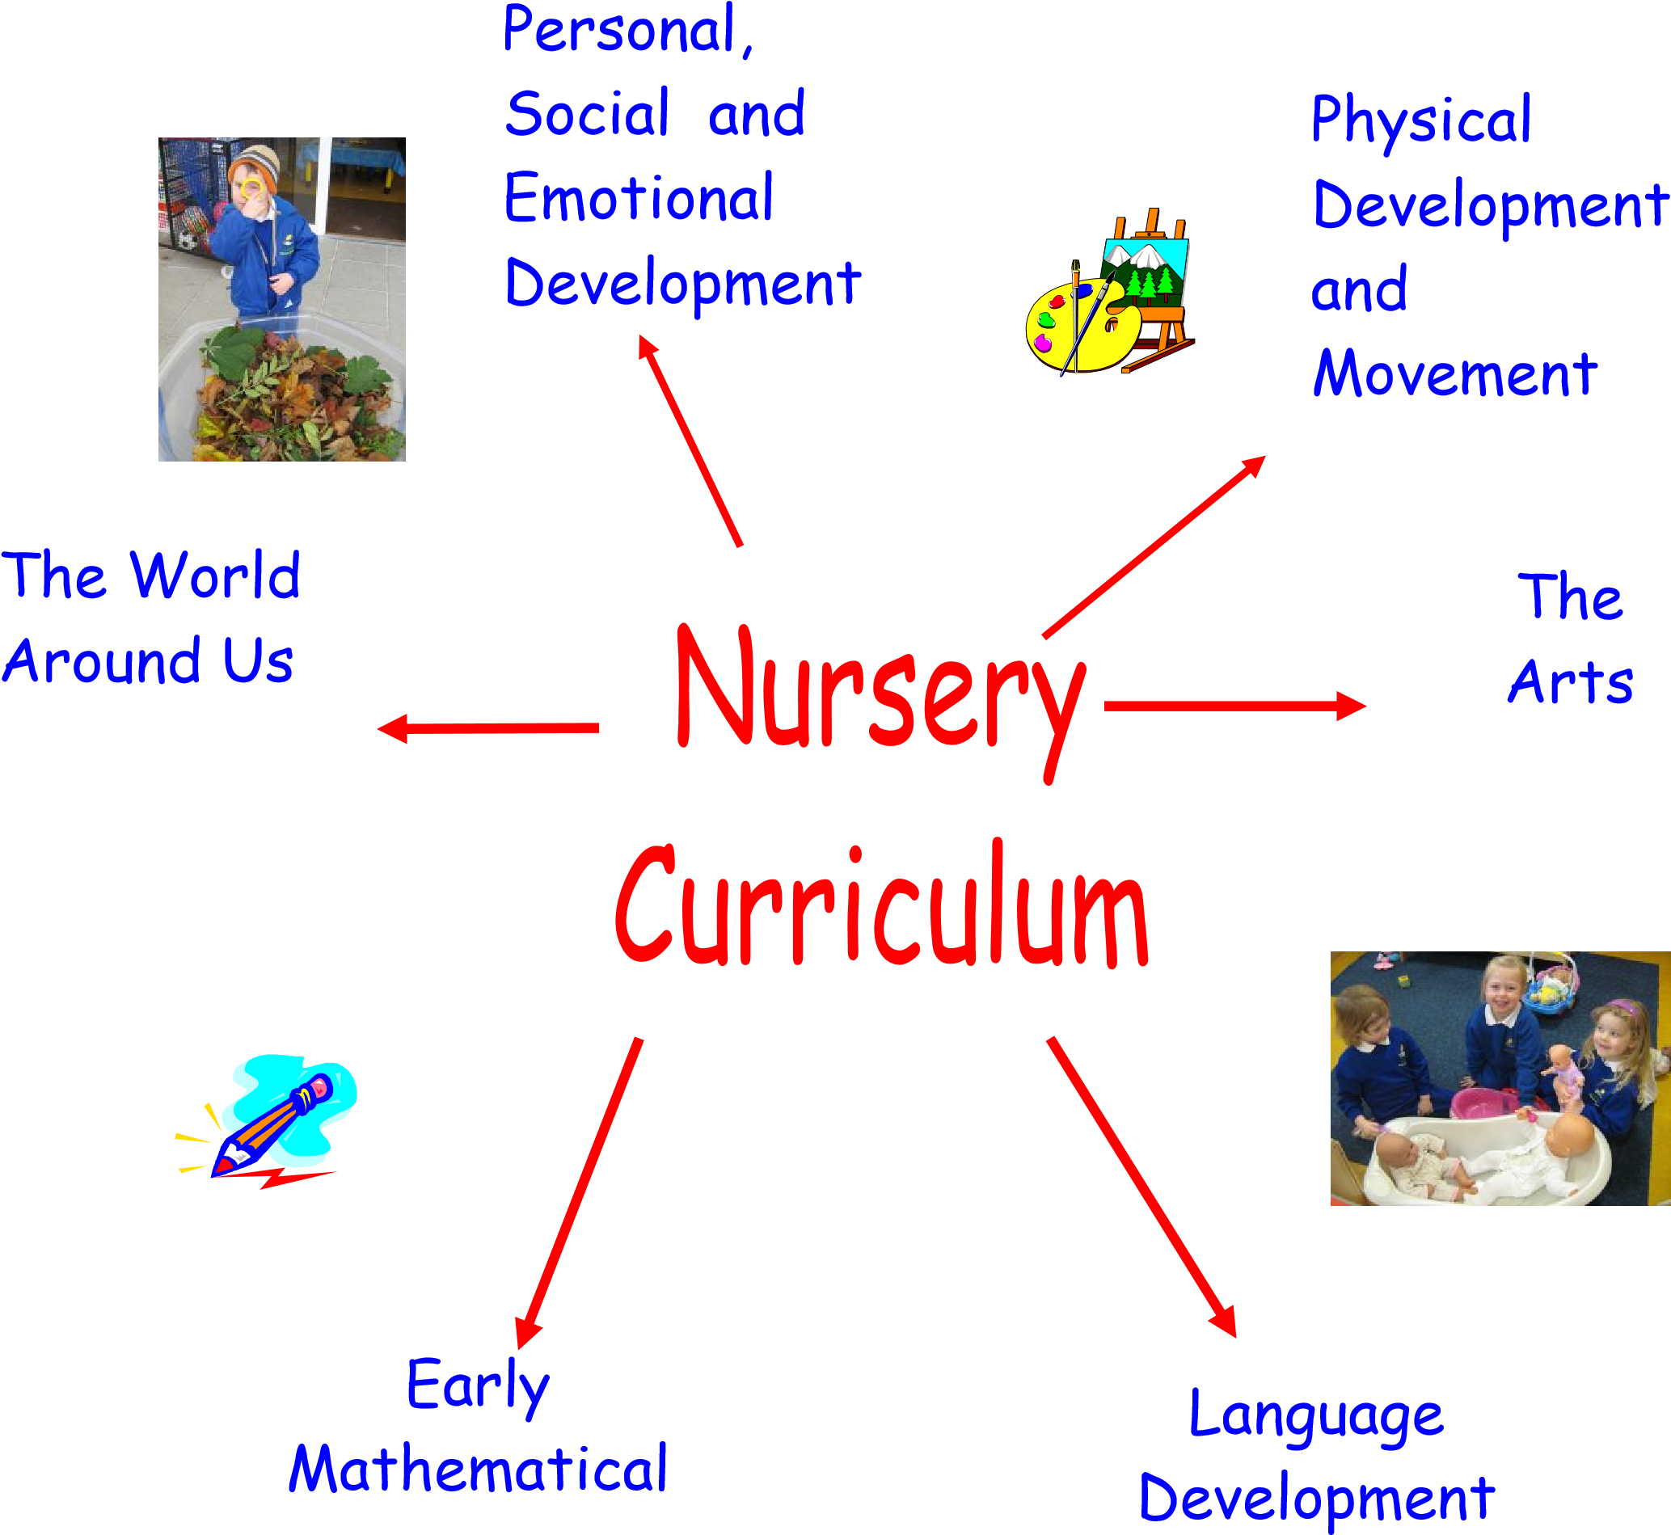

Key Objective 3

We will endeavour to involve parents in their children’s education by establishing and maintaining vital links between the child, home and the school.
Bal
lydown
Nursery

Child

Parents

The Structure of Partnership (2015 – 2016)

- We operate an open door policy for our Nursery parents – please take the opportunity to speak to your child’s teacher when you bring your child to class or when collecting him/her in the afternoon.

- Regular information is posted on the Nursery Notice Board and each child has his/her own tray where letters etc. are placed for parents to collect.

- You will receive monthly Nursery newsletters and rhymes/song sheets informing you of the topics, Nursery rhymes, songs, poems etc.

- Parents are also encouraged to support such activities as the Nursery Nativity and Sports Day.

- From time to time we may invite parents/grandparents etc. to assist practically in Nursery projects e.g. gardening, painting, etc.

- An active P.T.A in the school organises regular social and fund raising events which promote parent / teacher relations and generate additional resources for the Nursery class.

Curriculum Content and Organisation

Personal, Social and Emotional Development
Personal and social skills are developed through aspects of the curriculum. Our first aim is to help each child to settle into Nursery.
- Each child is treated as an individual with a valuable contribution to make to the Nursery.
- The children are encouraged to be kind and helpful, to cooperate with each other, to share, take turns and listen to each other.
- An enthusiastic and curious approach to learning is promoted.
- Each child learns to return toys to their ‘home’ when they have used them.
- Concentration skills are developed as children are encouraged to persevere until an activity is complete e.g. finishing a jigsaw.
- An understanding of the nursery rules and the need for these rules are promoted e.g., we walk inside so that we do not fall and hurt ourselves.

Language Development
We provide a range of opportunities to promote each child’s development of language.
- The children take part in a range of experiences, which enables them to communicate with their friends and adults (e.g. playing in the home corner, playing games) and to learn new words.
- Each child’s listening and concentration skills are reinforced daily through for example, listening to stories and participating in Circle Time.
- The children have opportunities to enjoy books and develop pre-reading skills through listening to stories, ‘reading’ a book with a friend or adult in the library. Reading skills include teaching the children to look at and talk about pictures, to re-tell a story using the pictures, to look for letters out of their name, to look at a book from left to right.
- The children will be taught pre-writing skills beginning with mark making and encouraged to ‘write’ their own name.

Early Mathematical Experiences

All the children take part in activities to explore, enjoy and develop an understanding of:

- NUMBER - counting how many times we jump outside, how many children are in Nursery, beginning to add and subtract when singing number rhymes (e.g. Five currant buns), or sorting toys according to their colour and counting them.
- MEASURE - comparing different quantities such as heavy and light, full and empty, exploring what happens to a balance when objects are added.
- PATTERN - talk about and copy patterns, such as red, blue, red, blue or big, little, big, little and also those patterns found in wrapping paper, wallpaper, brick work.
- SHAPE AND SPACE - talk about simple shapes such as circle, square, triangle, rectangle. Exploring a variety of shapes and their properties through junk modelling etc. Looking for shapes ‘out and about’ in road signs, houses, vehicles and making shape pictures.
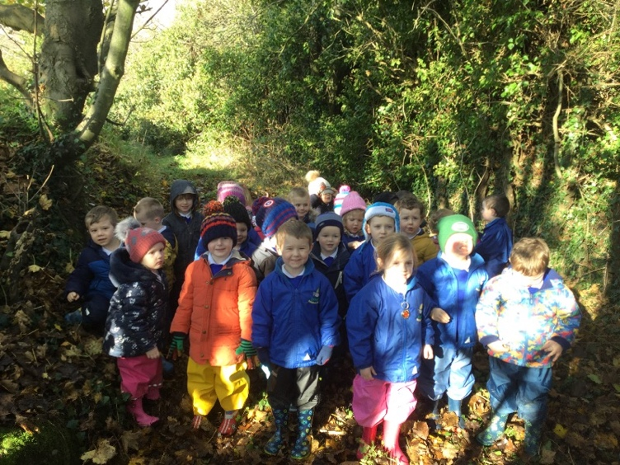
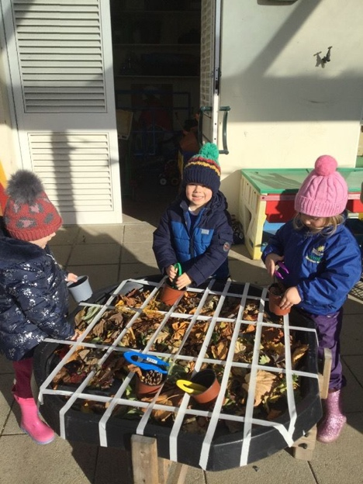

The World Around Us

The children will have opportunities to explore, question, investigate and experience the environment around them, for example:

- Talk about what they can see in the Nursery classroom/garden and help to look after it.
- Talk about the place in which they live and their journey to nursery.
- Use the computer and CD/tape player
- Name different living things and talk about their colour, skin, number of legs etc.
- Use different construction toys e.g. Building blocks, train set.

- Explore different materials, e.g. Investigate what happens when water freezes.

Physical Development and Movement (Indoors and Outdoors)
This includes the development of fine motor control and gross motor control:
- Fine motor control – for example, threading beads, holding a pencil, fitting a jigsaw together, using scissors.
- Gross motor control – for example, running, climbing and jumping.
We also promote an understanding of what the children’s bodies need to keep healthy and safe. Each child is encouraged to become independent and develop self-help skills, for example, use and put away toys, fasten coat.

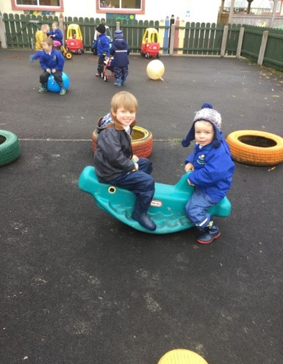
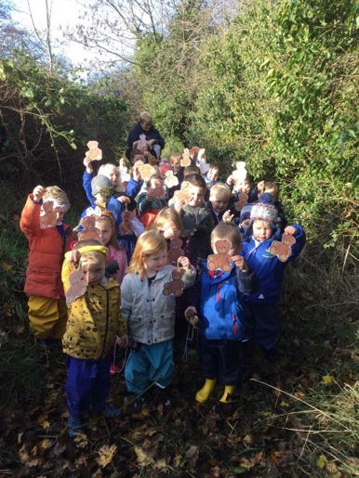
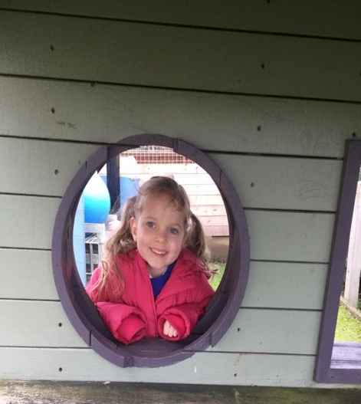

The Arts
This area includes art and design, music and movement, role-play and imaginative play. The children will have opportunities to share and explore thoughts and feelings.
- ART AND DESIGN - painting, printing, making models out of boxes, cutting and sticking.
- MUSIC AND MOVEMENT - singing songs with the actions, e.g., ‘Here we go round the mulberry bush,’ ‘I hear thunder’. Exploring loud and quiet sounds, long and short sounds.
•
- ROLE PLAY AND IMAGINATIVE PLAY - dressing up, playing in the home corner, hospital, shop, tent and castle. Acting stories, rhymes and songs we have listened to e.g. ‘Snow White’ and ‘Miss Polly had a Dolly’.
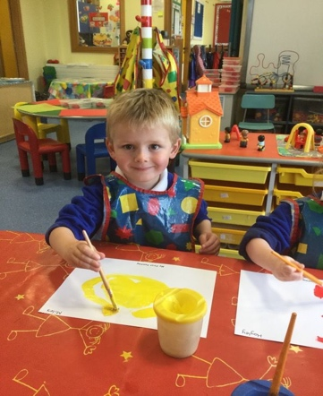
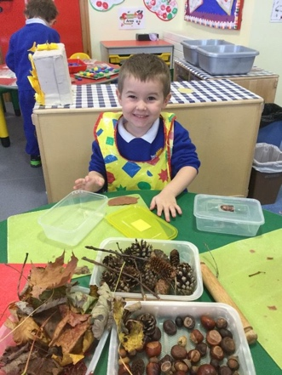

Special Educational Needs

As far as possible, the Nursery teachers meet the needs of each child. It is our intention to identify children with special needs as early as possible so that they may receive extra help and support. Specific problems may require the expertise of the support services such as the Support and Advisory Service, educational psychologists, speech and language therapists and social workers.

Children with more acute problems may require a full assessment so that their needs can be fully appreciated, understood and met.

In line with SENDO legislation, 2005, it is our policy, whenever possible, to incorporate special needs children into our Nursery classroom environment.

Assessment and Record Keeping

Ongoing assessment and record keeping includes a portfolio, record of achievement and teacher observation records. Formal consultations will take place on two occasions during the school year – in October 2021 and February 2022.

Complaints Against Curriculum Provision

In accordance with the School's policy of involving parents in the education of their children, in those cases where parents consider that the curriculum provision is not satisfactory, they are welcome to express their concerns. This should be done according to the following procedure.

In the vast majority of cases the problem will be solved by speaking to the nursery teacher. In the case of serious complaints, the concerns should be specifically detailed in writing and given to the Principal to enable the matter to be examined and a reply to be made.

Stage One - Contact Principal directly in writing
Stage Two - Put in writing for the consideration of the Board of Governors

Pastoral Care Arrangements Including Child Protection

Acting in 'loco parentis,' the Nursery recognises that it has a responsibility to care for each child's physical and emotional well-being. We will endeavour to provide a comfortable and safe environment for the children, both in the learning situation in the classroom and at play outside. Mrs Walker and Mrs Matchett the Nursery Assistant will look after the children throughout their time in the Nursery. Children will be made aware of rules governing behaviour including appropriate ways to play and interact with each other and how to deal with conflict.

On the whole, your child’s teachers will look after the pastoral needs of the children in the class and attempt to resolve any worries or anxieties. Parents will be informed if there are continual signs of distress in school.
Parents should also inform the Nursery
immediately if the child shows any distress at home which may be Nursery related.

However, Mrs Irvine is the Designated Teacher within the school for Child Protection. Parents of Nursery children should feel at liberty to speak to her of their concerns and worries especially in matters of bullying, safety issues or other child protection matters including suspected abuse. All teachers refer such matters to her when they are brought to their attention.

If you have concerns in relation to child protection issues, please contact one of the following:
Mrs Walker – Child’s Nursery Teacher
Mrs Irvine – Designated Teacher for Child Protection
Mrs Lindsey – Deputy Designated Teacher
Mr Murphy - Principal

They will record these concerns on the appropriate Report Form. Following a period of consultation, which may include contact with outside agencies such as Social Services/Education Authority, you will be advised of the outcome by either the Designated Teacher or the Principal.

Positive Behaviour

In Ballydown Nursery, all children are treated with love and respect and all our procedures aim to reinforce this.

We also believe nursery staff and parents have an important role in helping children learn and show desirable behaviour. By working with the children we can create a positive atmosphere in which unwanted behaviour is managed effectively.

Our staff is aware of the theories on how young children learn behaviour and will create a positive environment by:-

- Acting as a good role model (social learning theory)
- Rewarding children for wanted behaviour and ignoring some inappropriate behaviour (behaviourist theory)
- Having positive and realistic expectations of children’s behaviour (self-fulfilling prophecy)

We also help the children show appropriate behaviour by giving clear guidelines on what is and is not acceptable by setting boundaries and goals. Good manners and a high standard of behaviour, appropriate to the age of the child, is expected throughout the year.

A record of behaviour will be kept and contents will be discussed with parents.

We will consistently reward good behaviour in one or more of the following ways:-

- With a smile
- Eye contact
- A whispered comment
- Sharing good news with the class
- Praise
- Applause
- Passing good news to parents/carers verbally or in form of photographs.

Nursery Uniform

- Our Nursery uniform comprises of a blue sweatshirt and tracksuit bottoms (available from Maxwells and Robin Fields) with a white polo shirt.
- Children also wear Velcro fastened trainers to help encourage independence.

We ask parents to ensure that all coats, shoes and other personal items are clearly labelled with your child’s name.

Meals, Drinks & Snacks

- All food at break time is prepared in the Nursery by the staff using fresh, natural, healthy options. Parents are asked to make a £3 weekly contribution to cover this and other costs such as cooking ingredients and replacement of some resources.
- Our healthy break has achieved a Boost Better Break Certificate.

- Dinner will be taken in the classroom and as our Nursery offers full time places only, we encourage all children to have a school meal. We will keep you informed of the cost of school meals (currently £2.50 daily).

- Free school milk is available daily to all children.
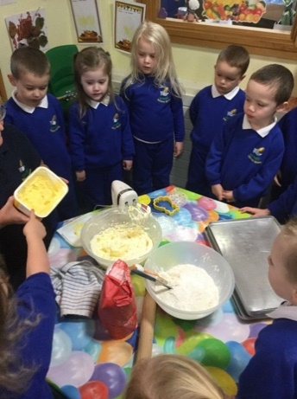
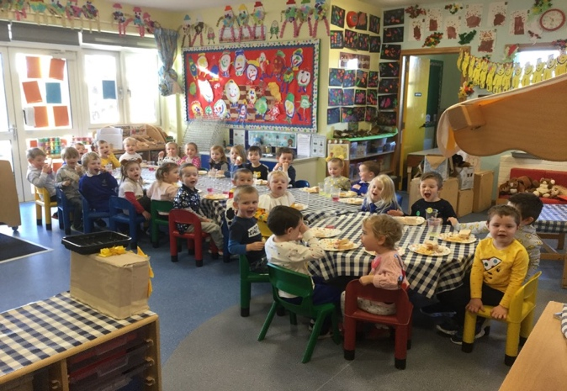

Pupil Data Collection Sheet Including Medical Information

When a child is sick or injured, the Nursery will, in the first instance, attempt to contact parents/guardian. If unsuccessful, the parents’ nominated contacts will be used.

Parents are asked to provide this information, on the Nursery’s computerised information sheets. If contact has not been made,
in more serious cases, the child's doctor will be contacted, or the child will be taken directly to the hospital/doctor.

Medical Information on Data Sheet

It is important for you to inform the Nursery if your child has specific dietary requirements or medical circumstances e.g. asthma /allergies etc. A letter may be requested from your child’s G.P. Children with asthma are expected to bring their inhalers to the Nursery each day.

You will be asked to complete your child’s Pupil Data Collection Sheet when you visit the school in June.

Holiday Arrangements

The school will confirm all holidays for 2021/22 at the meeting to be held in June 2021.

Charging and Remissions Policy

Education in the Nursery is provided free of charge. The Nursery may take part in trips and parents will be asked to cover the cost of transport and entrance fees. Written parental consent will be required before a child participates in such trips, and the Nursery reserves the right to cancel any visit if the number of voluntary contributions does not tally with the number of children participating.

Other Details

Other more specific information concerning daily routine, dinner, uniform etc will be provided at a meeting in June 2021.

Parents will be informed in writing of changes to any of the above information.

- Having read this prospectus, if you wish to obtain additional information or seek clarification, please ring the office and ask to speak to the Principal or our Nursery teachers.

- If you would like to visit our nursery, please contact the office to make an appointment 02840662738.

- If you select Ballydown Nursery, we look forward to welcoming you and we will work in partnership to make this a happy and exciting period in your child’s education.

