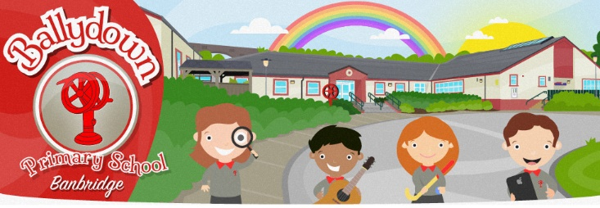

How to log on to MY SCHOOL from home
(My School, Newsdesk and Google Classroom)

- On your electronic device (laptop, tablet, phone) open google from your internet browser.
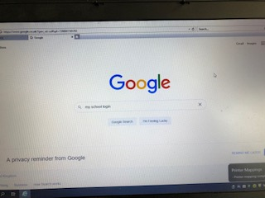
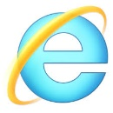

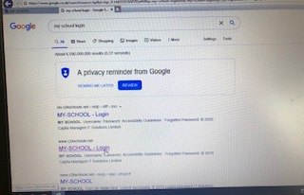
- Type in ‘my school login’.

- Select from the list:

- Type in username and password as supplied
(this is inside your homework diary)

e.g. username: jbloggs435 password: ********

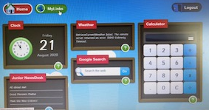
- Select ‘My Links’.

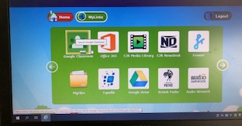
- Now you can choose what programme
you would like to use – Newsdesk,
Google Classroom etc.

How to access Google Classroom:

- Click on Google Classroom Icon.

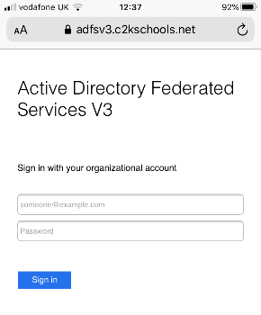
- If you see this screen, log in with your email address.
This is your username and @c2ken.net

e.g. jbloggs234@c2ken.net,
your password is the same as for My School

- When you log on through C2K My School, you should see our new Google Classroom. No code is required as each child is already enrolled in the class by the teacher. This is safer than issuing a code which others could use.

If you choose to download the Google Classroom app, and the device is used by more than one person, you must make sure you are always using your child’s email account.
apupil123@c2ken.net
you can check this by clicking on this icon.
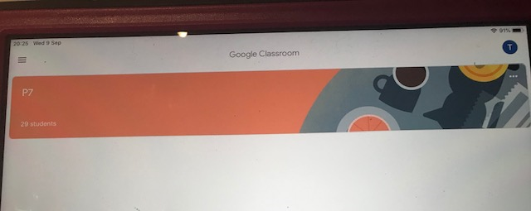
If there are multiple accounts listed
e.g mother@hotmail.com
father@yahoo.co.uk
CHOOSE YOUR CHILD’S ACCOUNT
apupil123@c2ken.net

