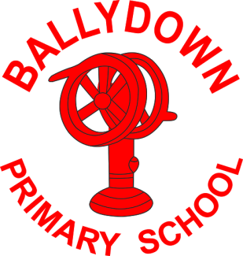
Ballydown Primary School & Nursery Unit
64 Lisnaree Road
Banbridge
Co Down
BT32 4JS
Tel:- 028 40662738

Principal: Mr B Murphy M.Ed. B.Ed. PQH(NI)

Dear Parents and P7

You may have heard the announcement today from AQE stating:

“The Board of AQE Limited met on 5th January 2021, and in light of the decision to close schools, has decided not to proceed with the tests planned for 9th, 16th and 23rd January 2021. The Board will now be consulting with member schools, and a further statement will be issued after that.”

We understand how disappointing this is for you all. We know all of the hard work you have put in working towards the test despite all of the uncertainty. It has been a very difficult year for you and all of the staff at Ballydown are very proud of you for your dedication and hard work over the past year. Remember this hard work has made you strong and resilient and ready to face the many challenges you will face in life. We know you are all stars!

We await further guidance from AQE and Grammar schools as to how the process for selection will now take place. At present we are not aware of what is to be put in place, but we will work closely with the grammar schools and let you know as soon as we find out any further information.

Mr Murphy

