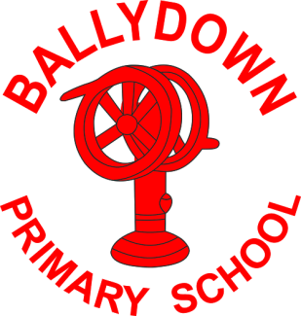
Ballydown Primary School & Nursery Unit
64 Lisnaree Road
Banbridge
Co Down
BT32 4JS
Tel:- 028 40662738

Principal: Mr B Murphy M.Ed. B.Ed. PQH(NI)

Dear Parent

As you will have heard from the media the NI Executive has announced that all pre-school, primary and secondary schools are to close and teach remotely until February half term. We are so disappointed to be closing school again for this extended period.

All learning can be accessed through Google Classroom. Hopefully everyone has been able to access this? If you have any problems, please contact us. We know it is a huge task for you as parents to be asked to home-school again, as well as balance your own work and other commitments. Please be realistic with your expectations of what can be achieved each day, especially if you have more than one child to manage; we totally understand how difficult this is.

Teachers in Nursery-P4 have put together some practical activities and resources that will be required for home schooling these younger children. Packs of test papers for P7 AQE pupils will also be available to collect (unfortunately, we still have to prepare for the possibility of the test going ahead in February!! We feel so sorry for our P7 children being messed around like this).

Our SENCO Mrs Baird has organised activities for some children with additional needs. You will be contacted if you need to collect anything for your child. If you wish to discuss anything about your child, please contact Mrs Baird at school Monday-Wednesdays.

Remember most of the activities for home learning do not need to be printed off. A lot of them can be completed from screens and answers written in a notebook or completed orally.

Packs can be collected from the assembly hall tomorrow (Thursday) afternoon between 2:30-4:30pm.

ALL parents must wear a face covering when collecting packs and enter the hall through the side door at nursery. Only 1 adult per family to enter the school and please respect social distancing.

Keep safe and well and hope to see you all soon,

B. Murphy

Principal

Phone: 028 4066 2738
E-mail: bmurphy490@c2kni.net website: ballydownprimary.org.uk

