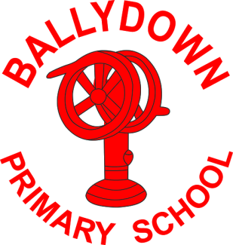
Ballydown Primary School & Nursery Unit
64 Lisnaree Road
Banbridge
Co Down
BT32 4JS
Tel:- 028 40662738

Principal: Mr B Murphy M.Ed. B.Ed. PQH(NI)

21st January 2021

Homelearning

Dear Parent

I hope you are all keeping well and managing to get through ‘juggling’ home schooling and working! It is fantastic to see how well most of you are doing and teachers are delighted with some of the work and feedback they are receiving. If anyone continues to have issues with using their Google Classroom or struggling with devices, please contact me as soon as possible.

Unfortunately, the Covid situation has not improved, with continuing high figures in our area and increasing numbers of people developing serious complications. There is a strong possibility that home-schooling may continue for a longer period of time. Our children’s education is certainly going to begin suffering as a consequence of an extended period of school closure. All children must be engaging in some form of home learning on a daily basis.

The Education Authority has asked for a roll call to be kept as to the level of engagement of children in home learning. We have been asked to record children who are engaging in their homeschooling and record those who do not as absent, unless they are ill. Teachers will be keeping a daily roll call record from next week. If your child is ill or your household has been affected by Covid please let us know so this can be recorded.

From Monday 25th January your child (P1-P7) will be asked to:

- Answer a roll call in their Google Classroom. You will find this in the classwork section of their Google Classroom and simply answer yes or no.
- Teachers will also be asking for assignments/tasks which must be submitted each week. This will include, for P2-P7, their Friday Round-up results. KS2 may also assign work through Purple Mash.
- You will find all of your child’s assignments for submission in the classwork section of their Google Classroom.
- Your child’s teacher will let you know what must be submitted and how. It may be just to click ‘hand-in’ or ‘’done’ to say it has been completed or you may be asked to submit the piece of work or a picture of it.
- This submitted work is the only way teachers are going to be able to assess your child’s progress for this term.
- Completed work should not be put in the class stream, but submitted privately to the teacher.
- Please keep the stream free for general teacher comments or feedback.

If you are having trouble navigating Google Classroom, then please contact us or access the many help sheets and videos available online. Teachers will be totally understanding of any technical or other issues you may be having; but please do keep them informed using the private comment tool.

We totally understand that it is very difficult to manage all of this, especially if you have more than one child, sharing devices and are also working. Therefore, teachers will allow to the end of a week for work to be submitted to allow for flexibility.

Once again please get in touch if you are having any difficulties managing home-schooling or with access. I know some households are under extreme pressure at the moment. Do not hesitate in contacting me to discuss. Children with additional learning needs may find home learning more challenging. Teachers and classroom assistants have sent additional material for some of these children. Please contact your child’s teacher if you are struggling with this. We will do everything we can to help or support you and your child. Thank you all for your support and hard work supporting your child’s learning.

Thank you for all of your kind messages asking about staff who have been ill with Covid. Everyone is beginning to improve, which is great news. We hope they all make a speedy and full recovery.

Let’s hope for a return to some normality, soon and to see all of our children back in school, where they belong.

Keep safe and well,

B. Murphy

Principal

Phone: 028 4066 2738
E-mail: bmurphy490@c2kni.net website: ballydownprimary.org.uk

