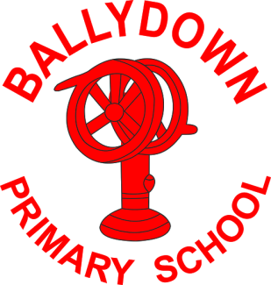
Ballydown Primary School & Nursery Unit
64 Lisnaree Road
Banbridge
Co Down
BT32 4JS
Tel:- 028 40662738

Principal: Mr B Murphy M.Ed. B.Ed. PQH(NI)

Dear Parent

Thank you all for your hard work this week on Google Classroom. It is great to see how many children are accessing this and the responses teachers are receiving are excellent. Remember to make use of the teaching videos to go with the learning, as they will help your child with the completion of their tasks.

If you have any technical issues, please get in touch with us as soon as possible. As we have said before we understand the challenges of juggling home-schooling, work, family etc. If you are struggling with anything, please do not hesitate in getting in touch with either your child’s teacher or contact me at school. It is okay to have a ‘bad day’, we are all finding things tough at the minute.

As you will have heard in the media schools will not return before Monday 8th March, at the earliest. There will be at least two more weeks of home-schooling after the half term break (15th – 19th February). P1-P4 and those with additional learning needs will need some additional reading and support materials for this. To facilitate this:

- 1st-5th February can we ask that all P1-P4 pupils return their reading books in their named folder. There will be a box for each class in the assembly hall between 9am-2pm, each day.
- Staff will then issue a new set to their folders for P1-P4 which can be collected the following week Thursday 11th and Friday 12th February from the assembly hall, between 9am-2pm.
- Any other children who will be required to collect work will be informed.

Thank you all so much for your continued support. One ‘final push’ and then let’s hope that the ‘end is in sight’ and life can return to some sort of normality by the second half of this year.

Keep safe and well,

B. Murphy

Principal

Phone: 028 4066 2738
E-mail: bmurphy490@c2kni.net website: ballydownprimary.org.uk

