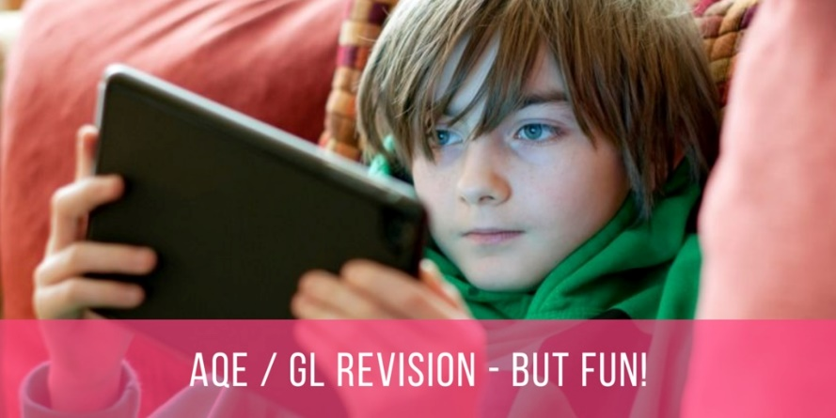
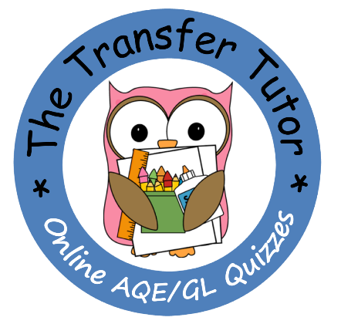

THE TRANSFER TUTOR – 50% OFF SCHOOL OFFER

Dear P6 Parent

As part of our school’s support for children going through the transfer test, we have teamed up with The Transfer Tutor App to offer you an amazing deal on a licence for your child. The normal price is currently £55 for a P6 licence, but through working with the school, we can secure a special price of only £25 per child.

If you aren’t already aware of The Transfer Tutor, it is a great resource where kids log on using the internet and complete quizzes in Maths and English. All these quizzes are broken down into different topics and directly aligned to the AQE and GL specification, so it is easy for the child to focus on one particular area at any time and hone their skills and knowledge.

Also as the child is doing these quizzes on their tablets, phone or computer there are some great technological features available, e.g. the child can use a Hint button if they get stuck and this will guide them to help them work out the answer, and a progress email sent to the parent’s email address when they have completed a test. However, the real beauty is the fact that this is online, interactive and addictive as the quizzes have a fun element built into them.

If you would like your son or daughter to sign up to this resource, please access the website link shown below, complete your details and send payment of £25 via the many options offered. The licences will then be processed by The Transfer Tutor directly, so please look out for your email and text from them.

TO PROCEED - GO TO THIS URL ON ANY DEVICE:

www.thetransfertutor.co.uk/parent-school

