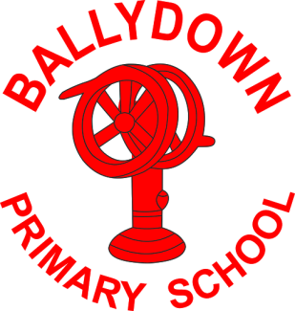
Ballydown Primary School & Nursery Unit
64 Lisnaree Road
Banbridge
Co Down
BT32 4JS
Tel:- 028 40662738

Principal: Mr B Murphy M.Ed. B.Ed. PQH(NI)

Return to School

Dear Parents

You will have heard about the planned phased return to school from the media. A further review yesterday has confirmed that the return guidelines issued at the end of last week will stand. Unfortunately, this means that not all of our pupils will be returning before the Easter break. Hopefully a slow, phased return will help to limit potential outbreaks. Below is the planned return for our school, following the current measures in place.

All of this is subject to change following further reviews by NI Executive.
22nd Feb- 5th March | Home-schooling for all pupils continues
8th -19th March | All Nursery & P1-P3 return to school for 2 weeks
22nd-26th March | All Nursery & P1-P3 Home-schooling for 1 week
8th-26th March | Home schooling P4-P7 continues for 3 weeks
Monday 29th March- Friday 9th April | *EASTER Holiday- School closed for all pupils for 2 weeks
Monday 12th April | Proposed return to school  for all pupils (this may be phased).
*Please note we have moved our planned Easter break forward by one week, if current measures are maintained, to allow for a much needed extra week of teaching time in term 3 and one less week of home-schooling.

Let’s hope this will be our last lockdown and we can have our classrooms filled again and hear the laughter of children in our playgrounds.

Thank you all once again for all of your support and hard work. Please contact me if you have any concerns or questions.

Keep safe and well.

B. Murphy
Principal
Phone: 028 4066 2738
E-mail: bmurphy490@c2kni.net website: ballydownprimary.org.uk

