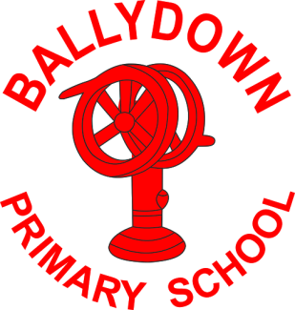
Ballydown Primary School & Nursery Unit
64 Lisnaree Road
Banbridge
Co Down
BT32 4JS
Tel:- 028 40662738

Principal: Mr B Murphy M.Ed. B.Ed. PQH(NI)

Nursery-P3 Return to School

Nursery-P3 pupils will return to school from Monday 8th March.

- School opens from 8:45am
- Nursery collection from 1:30pm
- P1 1:45pm, P2 1:50pm, P2/3 1:55pm P3 2:00pm
- Buses will be in operation Ulsterbus 2.00pm, Minibus 1:45pm

- Dinners available for Nursery-P3 (please book and pay through Ezpayment app). Dinner menus available on the website. Nursery please make sure you book a nursery meal. Only 1 choice for nursery and P1.
- Children will remain in their class bubbles, including playtime and dinners.
- Key worker children P4-P7 may attend 8:45am-2.05pm (may exit with P1-P3 siblings). Please inform Mr Murphy via email by Friday noon of each week, if your child will require supervision, to help us ensure we have adequate staffing in place. Unfortunately, dinners will not be available to key worker pupils at this time.

- Please respect social distancing guidelines whilst in the school grounds. Face coverings should be worn.

We are really looking forward to welcoming our Nursery-P3 children back into school. Hopefully we will see a full return after the Easter break. The school has been undergoing a major face lift during this period of lockdown. Work should be finished by the end of March. Please be cautious of work vehicles etc. when in the school grounds. The school will look fantastic when the work is completed.

Take care and keep well,

B. Murphy
Principal

Phone: 028 4066 2738
E-mail: bmurphy490@c2kni.net website: ballydownprimary.org.uk

