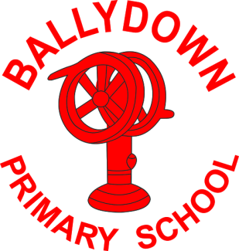
Ballydown Primary School & Nursery Unit
64 Lisnaree Road
Banbridge
Co Down
BT32 4JS
Tel:- 028 40662738

Principal: Mr B Murphy M.Ed. B.Ed. PQH(NI)

18th March 2021

Return to School

Dear Parent

We are delighted to be finally able to welcome all children back to school from Monday 22nd March. It will be lovely to see you all and give everyone a chance to settle back into school routines before the Easter break. The school building is looking fantastic, as our building and re-rendering work is almost complete. It is looking like a new building, ready to welcome the children back.

At the moment guidance still asks us to limit social contact and to minimise mixing of children and adults within the school grounds. Therefore, we will continue to operate within class bubbles and continue with the staggered a start and finish to the school day for next week, until we receive further guidance.

Start and finish
School doors will be open from 8:45-9:15am to allow for a more staggered arrival at school.

 | Enter and exit
Red Area (P1R, P1W, P2W) | P1/2 area steps
Blue Area (P2/3, P3, P4, P4/5) | Main front door
Green Area P5, P6, P6/7, P7 | Assembly hall door

 | Finish time
Nursery | 1:30pm
P1 | 1:45pm
P2 | 1:55pm
P2/3 | 2:00pm
P3 | 2:05pm
P4-P5 | 2:15pm
P6-P7 | 2:25pm
*Older siblings may leave with younger siblings P1-P7
Buses
EA buses will leave at 1:45pm approx.
Ulsterbus leaving at 2pm approx.

Hygiene
Children will wash hands on arrival to classrooms. Hands will be cleansed before eating, after play times and before going home.

Classroom tables will be cleaned before eating times and handles/touch points will be cleaned regularly throughout the day by classroom staff.

Children are encouraged to bring their own hand sanitiser to be used during the day.

Please DO NOT send your child if they are displaying any Covid-19 symptoms. Temperature checks at home are strongly advised. Any child displaying symptoms in school will be isolated and appropriately supervised, before being sent home.

School Dinners
Dinners will be available to all pupils. Please book dinners through the Ezpayment App at the beginning of each week. Please check your account is cleared before starting back. If you are having any issues using the app, please contact us or call into the office. All balances should be cleared by Friday of each week, please.

We understand that some peoples’ circumstances may have changed due to Covid. If you think you may be eligible for free school meals, please contact the office for advice.

Easter Holidays
School will finish on Friday 26th March at the above finishing times. We will reopen for term 3 on Monday 12th April 2021. School dinners will be available on Friday. This will be a non-uniform day and teachers have planned a few Easter treats for snack time.

Thank you all so much for your continued support throughout these unprecedented times. At last we see an end to home-schooling! Thank you and well done on getting through it! Let’s hope that we can have an uninterrupted term 3 back in school.

Take care and I really look forward to seeing you all on Monday.

B. Murphy

Principal

Phone: 028 4066 2738
E-mail: bmurphy490@c2kni.net website: ballydownprimary.org.uk

