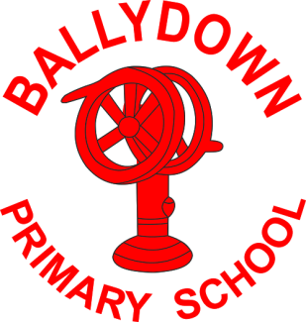
Ballydown Primary School & Nursery Unit
64 Lisnaree Road
Banbridge
Co Down
BT32 4JS
Tel:- 028 40662738

Principal: Mr B Murphy M.Ed. B.Ed. PQH(NI)

End of Term

School closes tomorrow, Friday 26th March for the Easter break. We will reopen on Monday 12th April 2021. School will finish at normal times and dinners will be available.

The PTA and teacher have provided treats for snack tomorrow and have planned some fun activities to mark the end of term.

Non-uniform
Many of you may have known Tracy Martin who very sadly passed away earlier this week, after a long battle with cancer. Tracy had very close links with Ballydown being a former pupil, parent, PTA rep and a member of our Board of Governors. At Tracy’s funeral, on Tuesday, she asked for everyone to wear bright clothes. As you know Friday will be a non-uniform day for all pupils. In honour of Tracy we want to ask for our staff and children to wear bright clothes. If anyone wants to make a donation to Marie Curie Cancer Charity, there will be a collection box at the entrance doors. Our thoughts and prayers are with Tracy’s family and friends at this very difficult time.

Thank you
We hope you all enjoy your Easter break. It has been a long and challenging term for everyone. It is hard to believe it has been a year from we first went into lockdown. Little did we know then of what was ahead of us. Thank you and well done to all of our staff for their hard work and effort in ensuring our children could continue their learning remotely. It has been a huge learning curve for staff and I think everyone has acquired new found skills. I also think that a few of our staff may be auditioning for movie roles!

We hope that the situation will continue to improve and we can go back to some sense of normality, soon.

Once again a huge thank you to you all for your support and efforts with your children during home-schooling. We look forward to seeing you all on 12th April ready for term 3.

Take care,

B. Murphy

Principal

Phone: 028 4066 2738
E-mail: bmurphy490@c2kni.net website: ballydownprimary.org.uk

