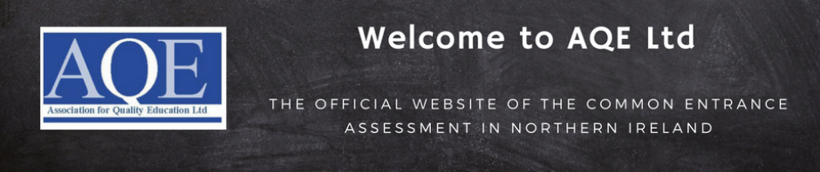

Home
AQE Update 18th May 2021
The Covid-19 pandemic has had a significant impact on the education of young people since March 2020. Their learning has been disrupted and the children hoping to take the AQE assessment in the autumn are understandably unsure about what lies ahead of them. AQE is fully aware of this, we have listened to the feedback from parents and the schools and we have placed the best interests of the child at the centre of our planning.
Following extensive engagement with its 34-member grammar schools and through them a large number of local primary schools, the Association for Quality Education Ltd. (AQE) can announce that applications for the 2021/22 Entrance Assessment will open on Tuesday 25th May 2021.
Given the impact that Covid-19 has had on schooling, AQE has engaged with schools and other stakeholders to ensure that its plans reflect the needs of the schools and, above all, the participating pupils. We have listened to the feedback and have made the assessment more accessible in recognition of the impact of the pandemic.
The recommendations from the schools were to hold the assessments before the Christmas 2021 break and to retain the three assessments to ensure maximum fairness for each pupil. As results are based on the two best papers out of the three, this allows room for a child to have an ‘off day’ without it impacting their result.
The Entrance Assessments will be held on the following dates:
- Saturday 20th November 2021
- Saturday 27th November 2021
- Saturday 4th December 2021
Due to the unprecedented circumstances, AQE has made revisions to this year’s assessment in order to recognise the disruption that Covid-19 has had on schooling. The assessments will follow the same general format as the past papers that many will be using for practice.
AQE has made modifications for this assessment, including:
- The provision of detailed English and mathematics support documents for the 2021/22 CEA papers which will be made available on the AQE website for parents and teachers to access.
- Some mathematics topic areas included in previous years will not be assessed in the 2021/22 assessment. Details of these topic areas will be available on the AQE website for parents and teachers to access.
- Some of the English passages have been shortened where appropriate.
- The mathematics and English questions have been revised to make them more accessible for this year’s assessment.
- Access has been provided free of charge to a large selection of past papers on the AQE website and others are available for purchase so that children can prepare thoroughly for the assessment (AQE will be providing a guide showing which individual questions will not be relevant for this year’s assessment due to the revisions described above).
- A sample paper, reflecting the 2021/22 assessment, will be provided free of charge on the AQE website.

