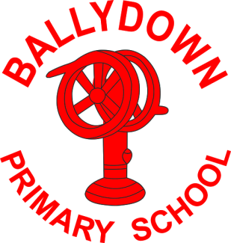
Ballydown Primary School
64 Lisnaree Road
Banbridge
Co Down
BT32 4JS
Tel:- 028 40662738

Principal: Mr B Murphy M.Ed. B.Ed. PQH(NI)

Sports Days

Dear Parents,

Due to Covid restrictions we unfortunately cannot do our tradtional sports day or invite parents along to spectate. We do plan on having a Fun Sports Day for each year group in June. We are going to hold off on setting a date until we see a ‘good weather’ week forecast! Children will be asked to wear sports kits on their sports day.

Kind Regards,

B. Murphy
Principal

Phone: 028 4066 2738
E-mail: bmurphy490@c2kni.net Website: ballydownprimary.org.uk

