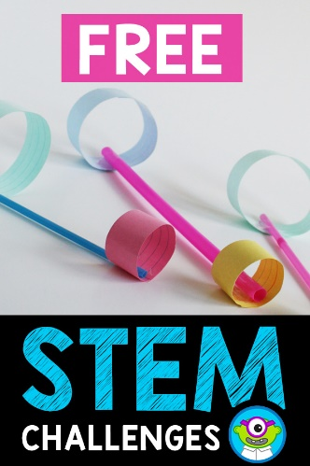

***P1 to P4 – 19th – 23rd July 9:30am - 2:30 pm***

***P5 to P7 – 26th – 30th July 9:30am - 2:30 pm***

***Spaces limited to 80 pupils per week***

*Ballydown P.S.*

*Summer*

*Scheme*

**Priority to**

**FSM, SEN, Pupils of Key Workers**

**Apply by email**