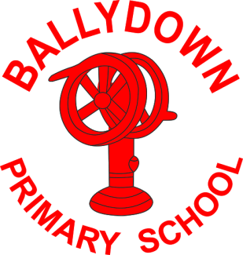
Ballydown Primary School & Nursery Unit
64 Lisnaree Road
Banbridge
Co Down
BT32 4JS
Tel:- 028 40662738

Principal: Mr B Murphy M.Ed. B.Ed. PQH(NI)

Covid Update- Close Contacts

Dear Parent,

As you are aware the cases of Covid are rising in our community. We wish to limit the spread of infection whilst continuing to minimise as much disruption as is possible to our children’s education and to your own work lives.

Please have plans in place in case your child’s class is identified as close contacts of a positive case. If this happens then please book a PCR test asap and keep your child in isolation until you get your result. Once your child receives a negative result (usually within 24 hours) they can return to school. It is advised by PHA that children are tested again 8 days after contact with a positive case.

Book a test- www.gov.uk/get-coronavirus-test or phone 119.

Please do not send your child to school if they are displaying symptoms. Continue to check temperatures and my advice would be to use lateral flow tests if you have any concerns. We want to keep school running as normally as possible.

Thank you for your understanding; as you know things are changing all of the time. We will keep you updated as much as possible.

Many thanks,

B. Murphy
Principal

Phone: 028 4066 2738
E-mail: bmurphy490@c2kni.net website: ballydownprimary.org.uk

