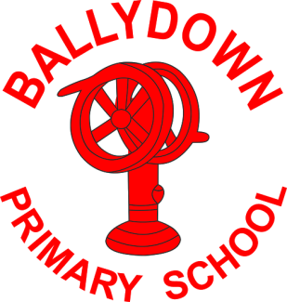
Ballydown Primary School & Nursery Unit
64 Lisnaree Road
Banbridge
Co Down
BT32 4JS
Tel:- 028 40662738

Principal: Mr B Murphy M.Ed. B.Ed. PQH(NI)

Piano Lessons

Dear Parents,

We have a piano teacher, Kerry Ramsey, available to take lessons on Mondays, beginning 20/9/21, for P4-P7 children. Lessons cost £6 for a 15min session. Lessons must be booked for half termly blocks. The first block will be 5 weeks (5 x £6=£30). If you would like for your child to begin lessons, then complete the attached form below. Places will be allocated on a first come basis. We will let you know if your child has gained a slot.

Yours sincerely,

B. Murphy
Principal

…………………………………………………………………………………………………………………….

Piano lessons 2021/22

I wish for my child to be enrolled for piano lessons.

Name of child:……………………………….. Class:……………………

Signed: ………………………………………………..

