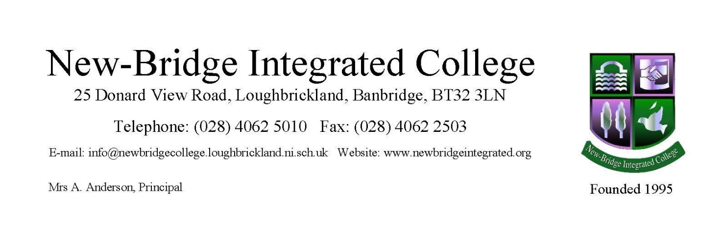14 December 2021

Dear Parent/Guardian

New-Bridge Information Session – Parents of P7 students

I hope you are all keeping well as we continue to navigate our way through difficult times. Unfortunately, like most schools this year we are unable to offer our normal Saturday Open Day which we are so disappointed about. Our Open Day gives our parents and prospective pupils the opportunity to visit different classrooms in the school and soak up our lovely family atmosphere but in trying to keep everyone safe, this is not an option for us this year.

We are always thinking of different ways in which we can connect with our prospective families and we hope our Website, Facebook, Instagram and Twitter posts will enable you to get a flavour of the wonderful work that is going in New-Bridge every day. Hopefully your son/daughter has had the opportunity to be involved in New-Bridge Lesson Roadshow 1 and current Lesson Roadshow 2 as we bring a little bit of New-Bridge magic into the primary classroom. Please check out our website https://newbridgeintegrated.org/open-day where you can scroll down to see all the wonderful Lessons from our Roadshow. You will also find in this section access to our virtual open day video and prospectus, which we continue to update. We hope to also be in a position to invite P7 students into New-Bridge in January for some taster lessons, restrictions permitting, as it is important that the students get some experience of what it feels like to be a Year 8 student in New-Bridge. Please watch out for reflections on the first term from our current Year 8 students in New-Bridge, as you might recognise some of the faces from last year’s P7 class.

In addition to this, I wish to invite you to visit New-Bridge for an Information Evening, in January, where we will provide you with some more details about our school. This will give you an opportunity to ask us any specific questions you might have. As you can appreciate, we cannot replicate our Open Day so this will be a planned socially distanced meeting in our school hall, with restricted numbers. We would ask that only one parent attends along with your son/daughter in order to manage numbers.

Ballydown Parents of Primary 7 students have been allocated the following time for the New-Bridge Information Session.

Thursday 13 January 2022 5pm -6pm

I would ask that you email Mrs E Lennon, Principal’s secretary to let us know if you plan to attend, so we have your details (elennon803@c2kni.net). If you have any questions in the meantime, please do not hesitate to give us a call or send us an email and we will gladly respond to your question. May I take this opportunity to wish you all a safe and happy Christmas.

Looking forward to meeting you in the New Year.

Yours sincerely
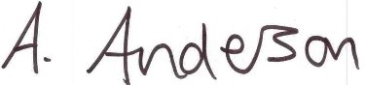
Mrs A Anderson
Principal

