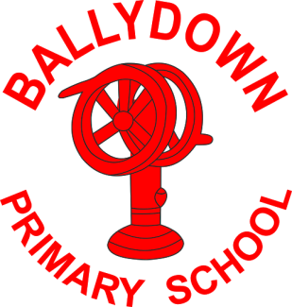
Ballydown Primary School & Nursery Unit
64 Lisnaree Road
Banbridge
Co Down
BT32 4JS
Tel:- 028 40662738

Principal: Mr B Murphy M.Ed. B.Ed. PQH(NI)

Dear Parents,

We have had a few cases of children testing positive for Covid, this week, and a cluster of cases in P4/5. Some have had more severe symptoms than others. Please be aware of your child displaying symptoms and use lateral flow tests if any concerns. All children in P4/5 Duke are encouraged to take a test before returning on Monday.

Take care,

B. Murphy
Principal

Phone: 028 4066 2738
E-mail: bmurphy490@c2kni.net website: ballydownprimary.org.uk

