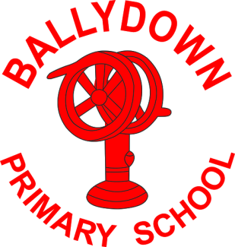
Ballydown Primary School & Nursery Unit
64 Lisnaree Road
Banbridge
Co Down
BT32 4JS
Tel:- 028 40662738

Principal: Mr B Murphy M.Ed. B.Ed. PQH(NI)

2-3 Club

Dear Parents

We are trialling a 2-3pm afterschool club for nursery-P3 children Monday-Thursday. This club will run from our nursery unit. £5 per session. Children will be supervised by classroom assistants and will take part in a range of outdoor and indoor activities. They will also receive a snack during the club. Children should be booked in using the booking form. Further forms available from office or our website.

Numbers will be limited. Booking and payment must take place by Thursday of the previous week. You will be informed on Friday of each week if a place is available on your chosen dates. Please send booking form and payment (cash) in a sealed labelled envelope, thank you.

*2-3 Club will begin Monday 18 September for P2 and P3 children only. Nursery and P1 will be included from when they are having dinners and doing a full day!

We hope you will find this club useful, as parents, to help with pick-ups and childcare arrangements. After trial we will aim to move to an online booking process.

Yours sincerely,

B. Murphy
Principal

