Ballydown PTA Pumpkin Competition

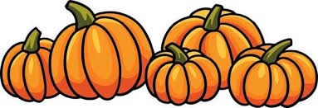

- Carve a pumpkin with any design you choose.
- Bring your carved pumpkin to school on Monday 23rd October to put on display outside school.
- Parents will be able to see the pumpkins when in school for interviews.
- Prizes for the most creative pumpkins.
- Pumpkins can be brought home on Friday 27th October.
£1 per entry

