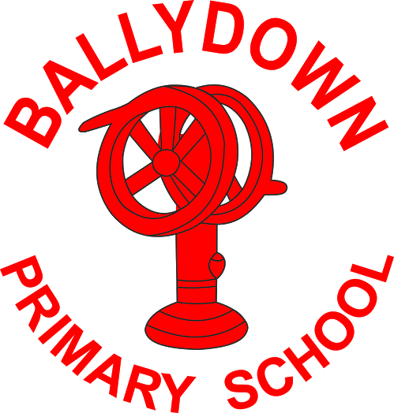

COMPLAINTS PROCEDURE
September 2019

Ratified: __________________________________________

Review Date: __________________________________________

Contents:

Foreword from the Principal

Aims of Complaints Procedure

School Complaints Procedure – at a glance

Scope of Complaints Procedure

What to expect under this Procedure?

Making a complaint

Foreword from the Principal
Here at Ballydown Primary School and Nursery Unit, we take complaints very seriously. We have the best interests of all our pupils and their families at the centre of all we do. In this regard, we encourage anyone with a concern to speak to us as soon as possible. If concerns are dealt with at an early stage, then they are more likely to be resolved and there is no unnecessary dissatisfaction.

Many issues can be addressed simply by talking to the relevant staff in school who will be happy to help. Open communication and regular engagement between the school, parents/carers and other stakeholders is vital to the effective management of our school.
We welcome open communication with our staff; parents / carers can speak to staff by: telephone - outside of teaching times, calling into school before 9.00am or by making an appointment. I can be contacted at any time by telephoning the school office or by speaking to me outside before or after school.
If you have a concern about your child, you should raise it or talk to the teacher as soon as possible. If your concern is related to a matter other than in the classroom, you should speak to the Principal. We take all concerns seriously and make every effort to resolve matters as quickly as possible.

Sincerely
B Murphy
Principal

AIMS
When dealing with complaints we aim to:

- Encourage resolution of all concerns as quickly as possible;
- Provide timely responses to concerns and complaints;
- Keep you informed of progress;
- Ensure a full and fair investigation of your complaint where appropriate;
- Have due regard for the rights and responsibilities of all parties involved;
- Respect confidentiality;
- Fully address your complaint and provide an effective response;
- Take appropriate action to rectify the issue and prevent it happening again where appropriate;
- Be responsive to learning from outcomes which will inform and improve practice within the school.

A copy of this Procedure is available on the school’s website or is available from the school on request.

Complaints Procedure – At a glance

Stage 1 Stage 2
Write to the Principal Write to the Chair of the Board of Governors

Time Limit
To help us resolve your complaint, please contact us as soon as possible. Unless there are exceptional circumstances, we will only consider a complaint within 6 months of you becoming aware of the issue.

Stage One
When making a complaint, contact the school Principal who will arrange for the complaint to be investigated. If the complaint is about the Principal, proceed to Stage Two. The school requires complaints to be made in writing. However, where this is not possible the school will make reasonable arrangements to support you.
Please provide as much information as possible including:

- Your name and contact details
- What the complaint is about
- What has already been done to try to resolve it and • What you would like the school to do.

The complaint will normally be acknowledged within 5 school working days and a response normally made within 20 school working days of receipt of the complaint.

These timeframes may need to be reviewed if complaints are ongoing during school holiday periods.

If you are unhappy with the outcome at Stage 1, your complaint may be progressed to Stage 2 which is overseen by the Board of Governors.

Stage Two

If the complaint is unresolved after Stage One, write to the Chairperson of the Board of Governors (care of the school and marked ‘private and confidential’), who will convene a subcommittee to review the complaint. Please provide as much detail as possible as indicated above.

The complaint will normally be acknowledged within 5 school working days and a final response normally made within 20 school working days from date of receipt of the complaint.

These timeframes may need to be reviewed if complaints are ongoing during school holiday periods.

Northern Ireland Public Services Ombudsman (NIPSO)

If following Stage Two you remain dissatisfied with the outcome of your complaint, you can refer the matter to the Office of the Northern Ireland Public Services Ombudsman (NIPSO).

The Ombudsman provides a free, independent and impartial service for handling complaints about schools in Northern Ireland. You have the right to complain to the Ombudsman if you feel that you have been treated unfairly or have received a poor service from a school and your complaint has not been resolved to your satisfaction.

A complaint should normally be referred to NIPSO within six months of the final response from the School. The school must advise in its concluding letter that the complaint may be referred to the NIPSO if you remain dissatisfied.

Contact details for NIPSO are:

Northern Ireland Public Services Ombudsman
Office of the Northern Ireland Public Services Ombudsman
Progressive House
33 Wellington Place
Belfast
BT1 6HN

Freepost: FREEPOST NIPSO

Telephone: 02890 233821
Freephone: 0800 34 34 24

Email: nipso@nipso.org.uk
Web: www.nipso.org.uk

1. SCOPE OF COMPLAINTS PROCEDURE

1.1 The Complaints Handling Procedure sets out how any expression of dissatisfaction relating to the school will be managed. By taking concerns raised by parents or others seriously at the earliest possible stage, we hope to resolve issues quickly and effectively.

1.2 Complaints with separate established procedures

Some examples of established procedures or appeal mechanisms are listed below. The list is not exhaustive. Your Principal/ Chair of Governors will advise you on the appropriate procedure to use when you first raise your complaint.
You may still take your complaint to NIPSO, should you remain dissatisfied upon completion of one of these procedures.

Exceptions
- Admissions / Expulsions / Exclusion of children from school
- Statutory assessments of Special Educational Needs (SEN)
- School Development Proposals
- Child Protection / Safeguarding

1.3 The school will not normally investigate anonymous complaints, unless deemed by the Chair of the Board of Governors to be of a serious nature. The decision of dealing with such complaints will be at the discretion of the Board of Governors.

3. WHAT TO EXPECT UNDER THIS PROCEDURE

3.1 Your rights as a person making a complaint

In dealing with your complaint we will ensure that you receive:

- Fair treatment;
- Courtesy;
- A timely response;
- Accurate advice;
- Respect for your privacy – complaints will be treated as confidentially as possible allowing for the possibility that we may have to consult with other appropriate parties about your complaint; and • Clear reasons for our decisions.

3.2 Your responsibilities as a person making a complaint

In making your complaint you should:
- Raise issues in a timely manner
- Treat our staff with respect and courtesy
- Provide accurate and concise information in relation to the issues you raise
- Use these procedures fully and engage with them at the appropriate levels

3.3 Rights of parties involved during the investigation

Where a meeting is arranged the complainant may be accompanied but not represented by another person.

This Procedure does not take away from the statutory rights of any of the participants.

3.4 Timeframes

Where concerns are raised with the relevant Teacher or Principal, a response will normally be provided during the meeting or within an agreed timeframe.

Stage 1 – Normally acknowledge within 5 school working days, response normally within 20 school working days

Stage 2 – Normally acknowledge within 5 school working days, response normally within 20 school working days

If, for any reason, the review of your complaint takes longer to complete, you will be informed of revised time limits kept updated on progress.

These timeframes may need to be reviewed if complaints are ongoing during school holiday periods.

3.5 Equality

The school requires complaints to be made in writing. However, where this is not possible, please contact the Principal who will make reasonable arrangements.

3.6 Unreasonable Complaints
The school is committed to dealing with all complaints fairly and impartially, and to providing a high quality service to those who complain.
There will be occasions when, despite all stages of the complaints procedure having been completed and the complaint has been reviewed by the Ombudsman, the complainant remains dissatisfied. If they try to re-open the same issue, the Chair of Governors will inform them that the procedure has been completed and that the matter is now closed. If the complainant repeatedly continues to contact the school with the same issue we may choose not to respond.

